**Crash Course Computer Science**

Early Computing: Crash Course Computer Science #1

* Charles Ranlett Flint was the founder of the Computing-Tabulating-Recording Company which later became IBM (International Business Machine’s Corporation)
* Herman Hollerith is widely regarded as the father of modern automatic computation. He chose the punched card as the basis for storing and processing information and he built the first punched card tabulating and sorting machines as well as the first key punch (The metal pins would pass through the holes in a card and into mercury which would complete a circuit, which would power an electric motor to turn a gear) and he founded the company that was to become IBM.

Electronic Computing: Crash Course Computer Science #2

* Colossus Mark I is regarded as the first programmable electronic computer.
* ENIAC (Electronic Numerical Integrator and Calculator), world’s first General Purpose, Programmable Electronic computer.
* Transistor was created -> uses quantum mechanics, typically have 2 electrodes separated by a semiconductor (sometimes conducts electricity, other times does not). Control wire attaches to a gate electrode
* We went from Mechanical Relays -> Vacuum tubes -> Transistors

Boolean Logic & Logic Gates: Crash Course Computer Science #3

* In computers, an ‘On’ state is when electricity is flowing -> representing true, the ‘Off’ state is when no electricity is flowing, representing false.
* Transistors work well with Boolean Algebra
* 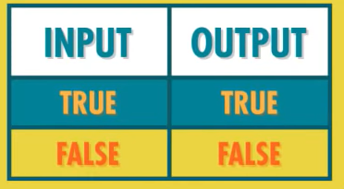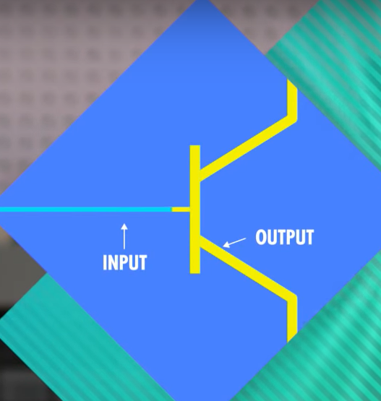Transistors have a control wire and 2 electrodes; control wire is the link. You can see the control wire as the input and electrodes as the output. With a single transistor, we have 1 input and 1 output. If we turn this transistor on, the output is on because current can flow through it, vice versa when input is off (electricity can no longer flow through when input of false).
* This circuit is not too useful as it is not doing much, we can however modify this circuit to create a NOT gate(next page).

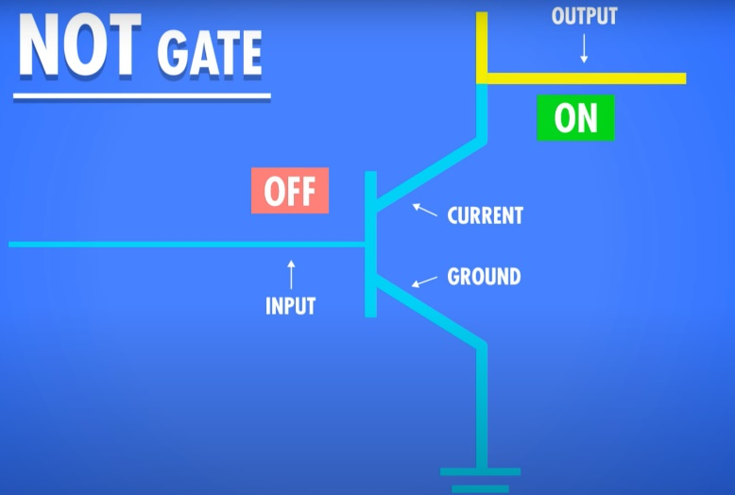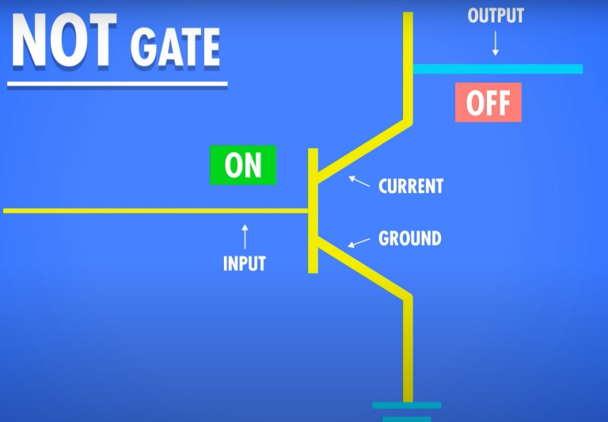NOT gate (current goes to where there is least resistance)

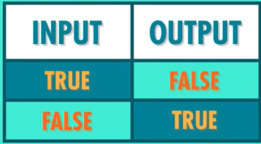

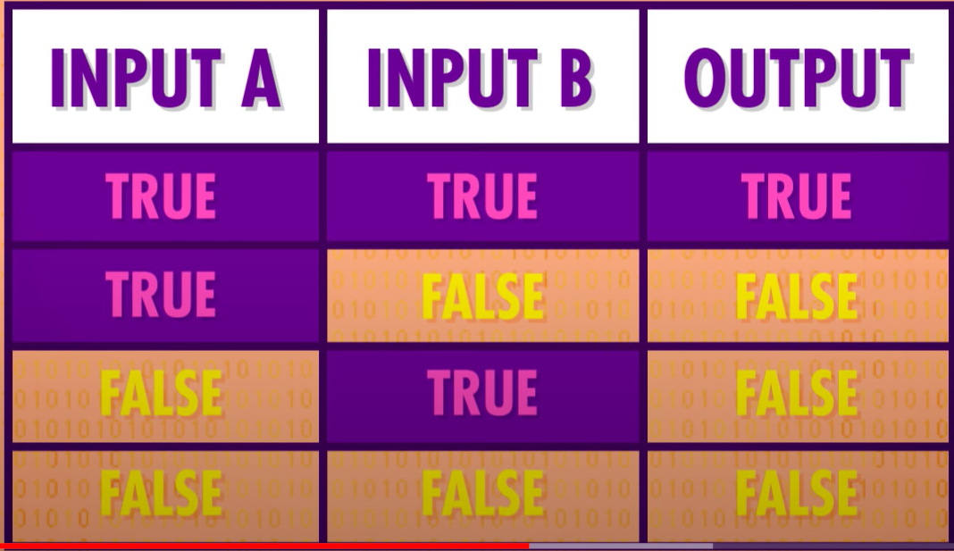AND GATE (takes 2 inputs)

* For an AND gate to work, both transistors need to be on therefore for inputs must be true for a true output otherwise current cannot get through

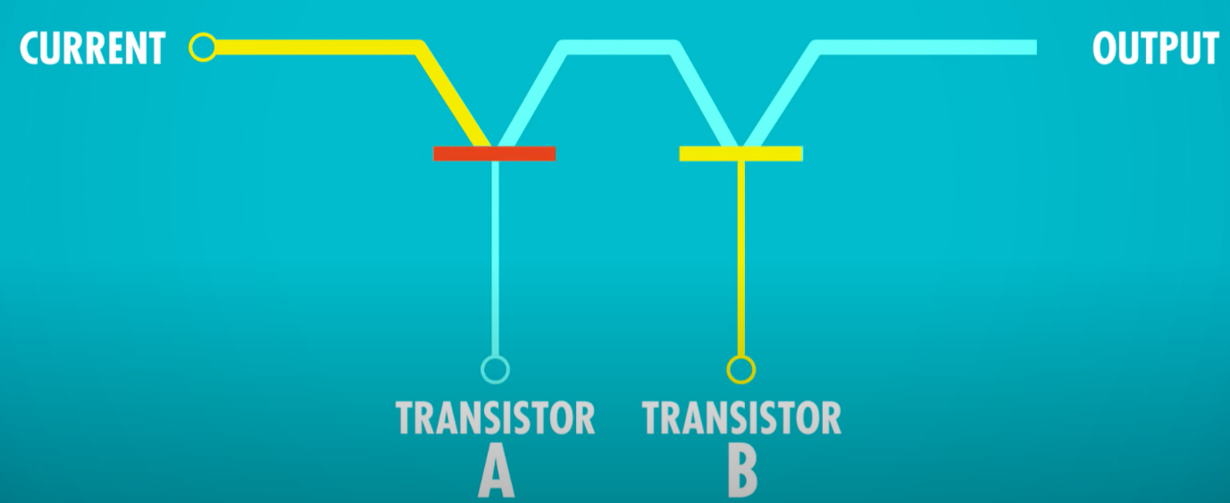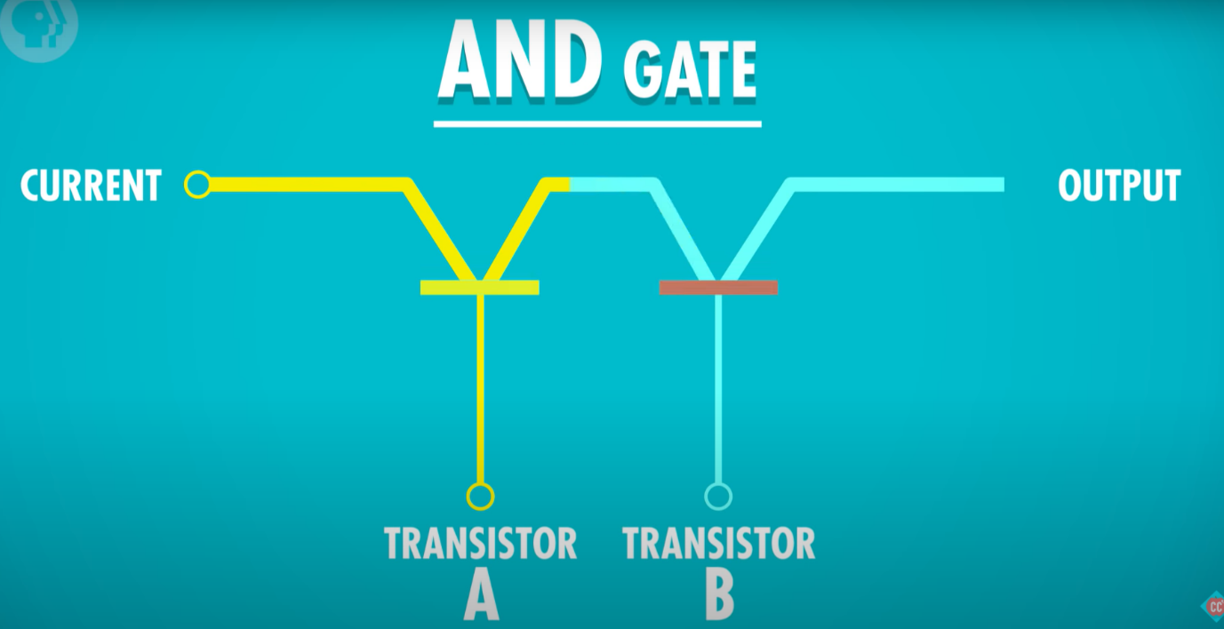

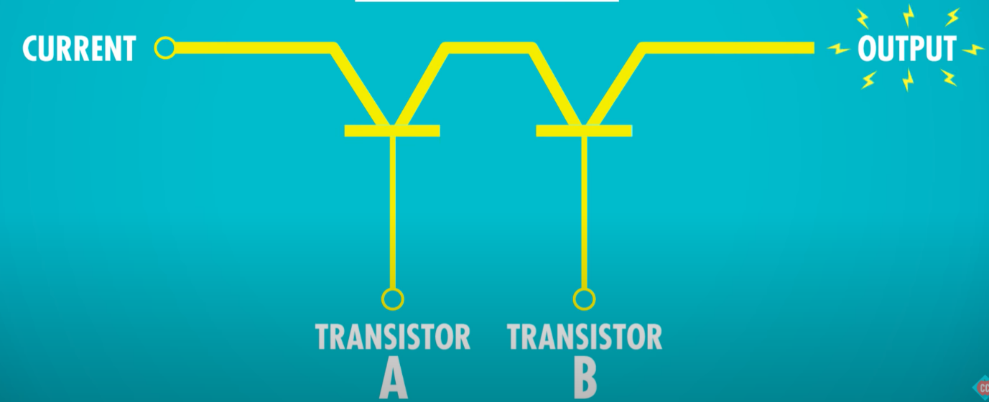

OR GATE (Takes 2 inputs)

* 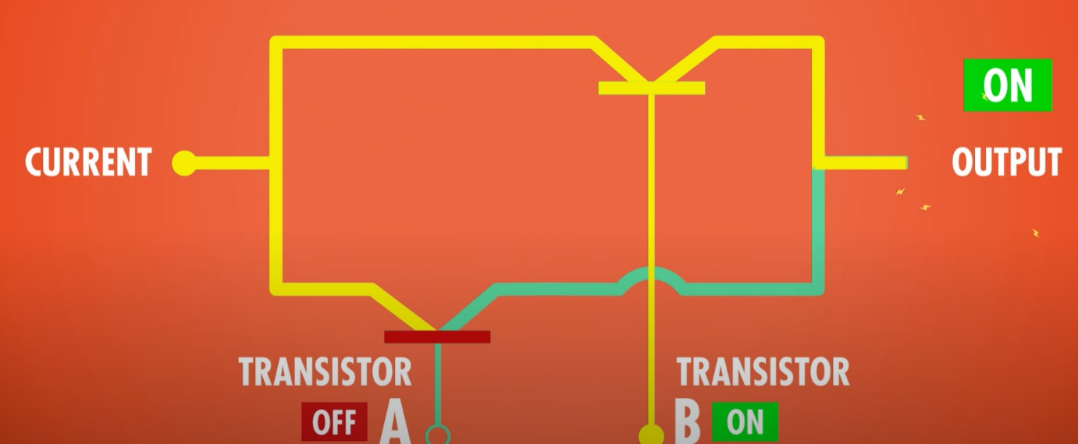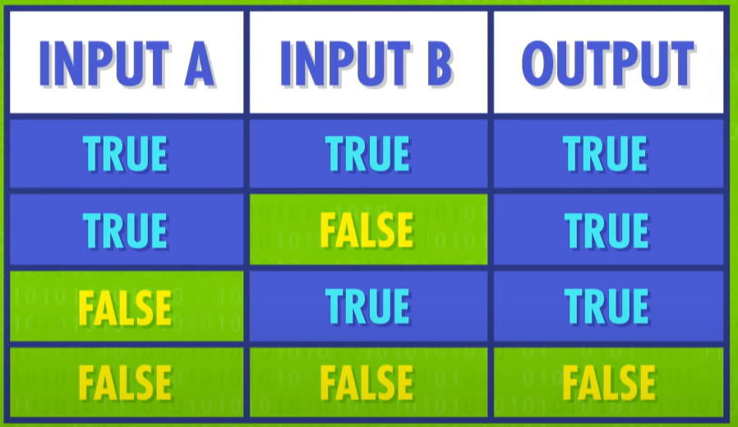For an OR gate to work, one transistor needs to be on to allow the current to pass

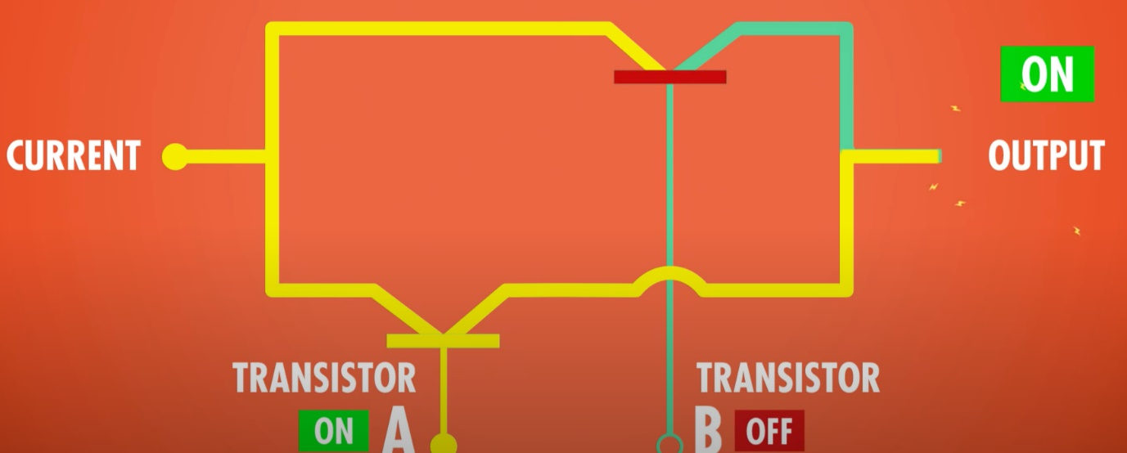

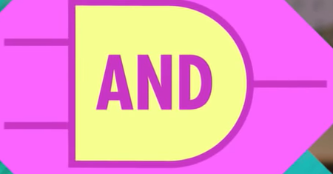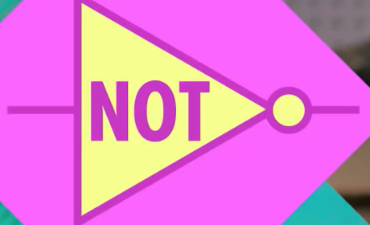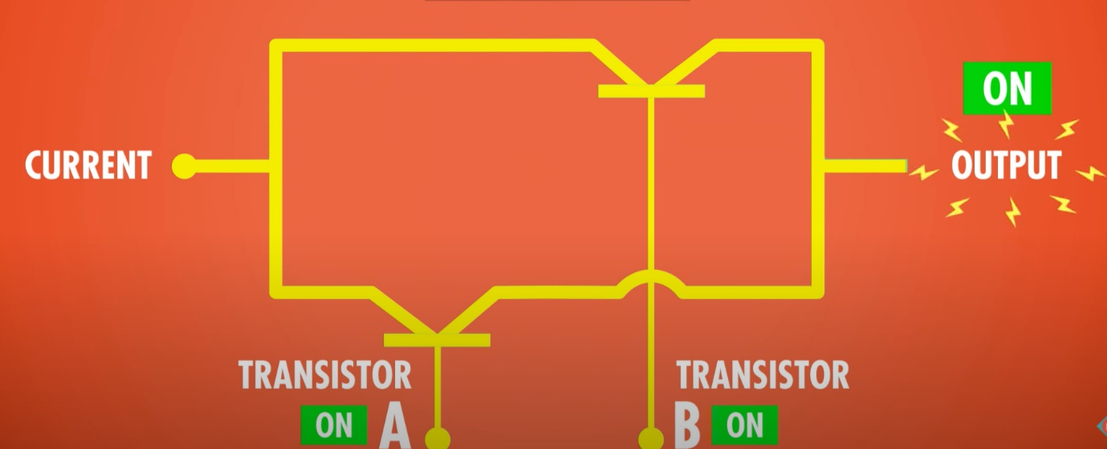Symbols

XOR Logic Table (2 inputs)

* XOR is also known as exclusive or, it has an exclusive property which is the true or true is false (True XOR True = False)

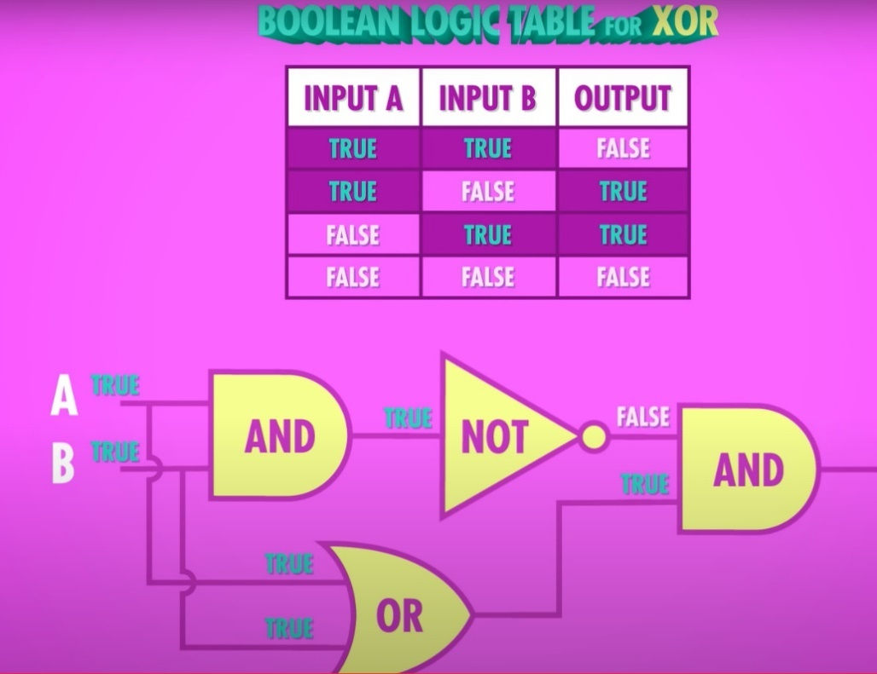

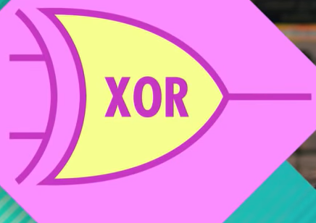

Representing Numbers and Letters with Binary: Crash Course Computer Science #4

* A Bit is a binary digit
* A Byte is 8-Bits (We have this term because 8 Bits is v. common)
* 10 Bytes is 80 Bits
* In Decimal SI (base 10), 1 **Kilobyte** is equivalent to **1000** bytes. On the other hand in Binary (base 2) system, 1 **Kilobyte** is equal to **1024** bytes (“In binary, a kilobyte has 2^10 bytes == 1024).
* Mega is a million bytes (MB)
* Giga is a billion bytes (GB)
* What are 32-bit/64-bit? Well e.g., 64-bit means it operates in chunks of 64-bits
* Computers can represent negative numbers and floating-point numbers
* Computers label locations in memory by addresses
* Computers use numbers to store letters, ASCII is a 7-bit code, enough to store 128 values.
* Sound and Pixels and everything on a computer is represented in binary.

How Computers Calculate - the ALU: Crash Course Computer Science #5

* Computation of numbers is handled by the ‘Arithmetic & Logic Unit’ or the ALU
* ALU is the mathematical brain of a computer, it does all the computation for everything
* ALU consists of 2 units, the arithmetic unit and logic unit
* The half adder has 2 inputs, A and B, and has 2 outputs: The sum and carry.
* The full adder has 3 inputs, A and B and carry and has 2 outputs: The sum and carry
* 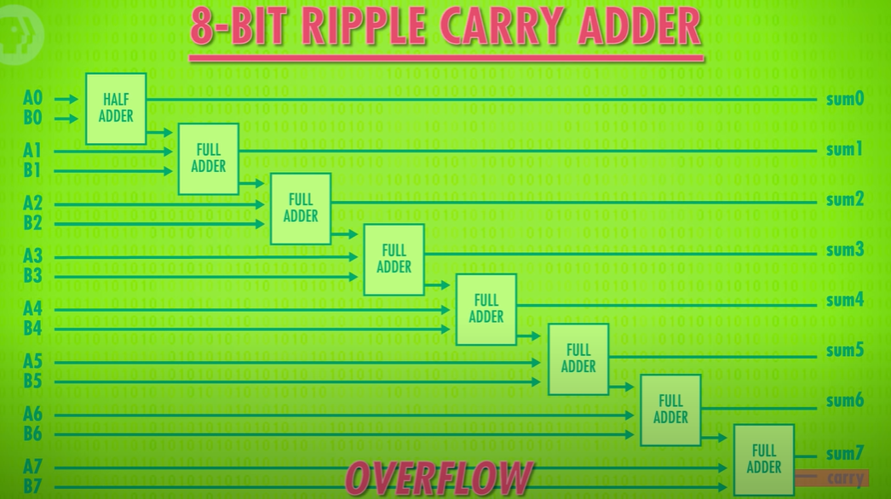An overflow occurs when the result of an addition is too large to be represented by the number of bits you are using (usually causes errors and unexpected behaviour)

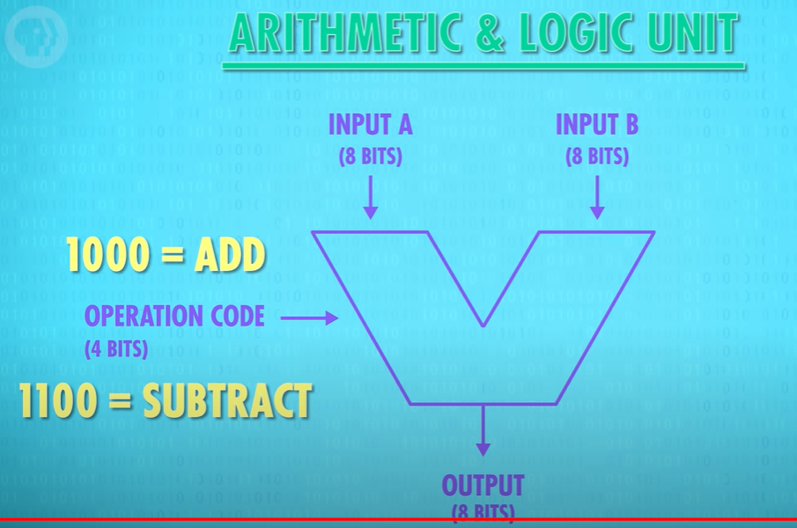

The ALU has two main functions:

* It performs arithmetic and logical operations (decisions). The ALU is where calculations are done and where decisions are made.
  + Arithmetic Unit performs Calculations
  + Logic unit gives flags for logical operations
* It acts as a gateway between primary memory and secondary storage . Data transferred between them passes through the ALU.

Registers and RAM: Crash Course Computer Science #6

* Persistent memory-> Survive without power
* 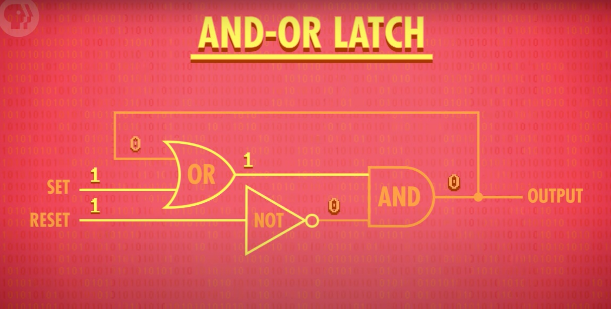RAM -> Random Access Memory, stores states if the power stays on
* The And-Or-Latch has 2 inputs; Set & Reset.
  + Set to 1; sets output to 0
  + Reset to 1; sets output to 0
  + If Set and Reset is 0; Just gives the output from before (memory)
* 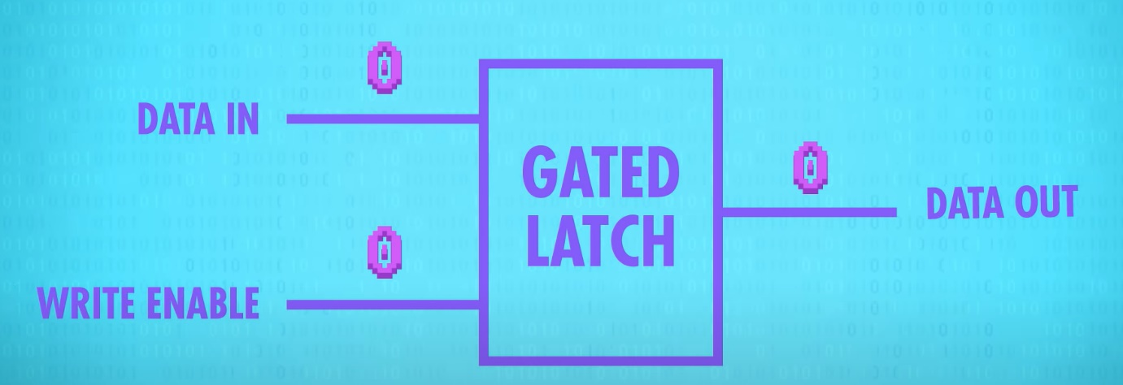The action of putting data into memory is writing, getting info out is reading
* 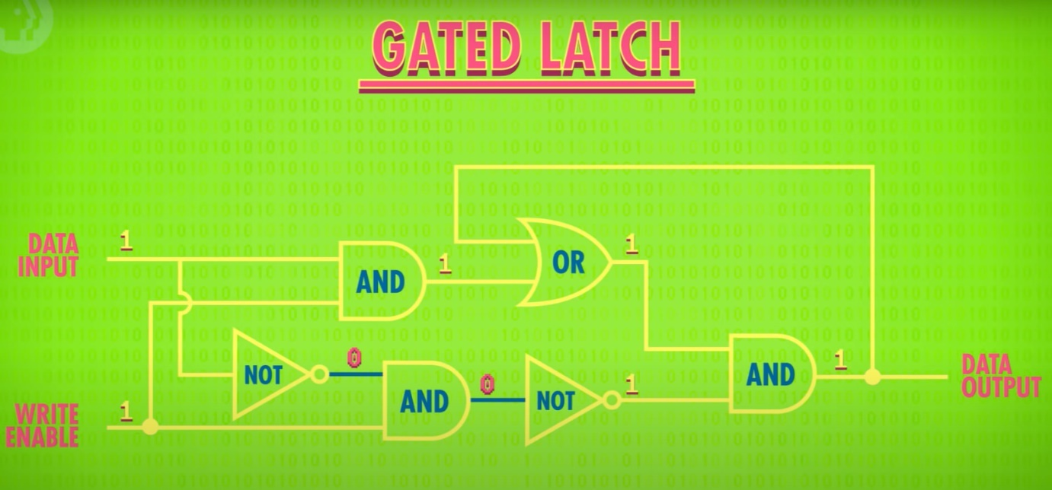The Write Enable Wire is off
* 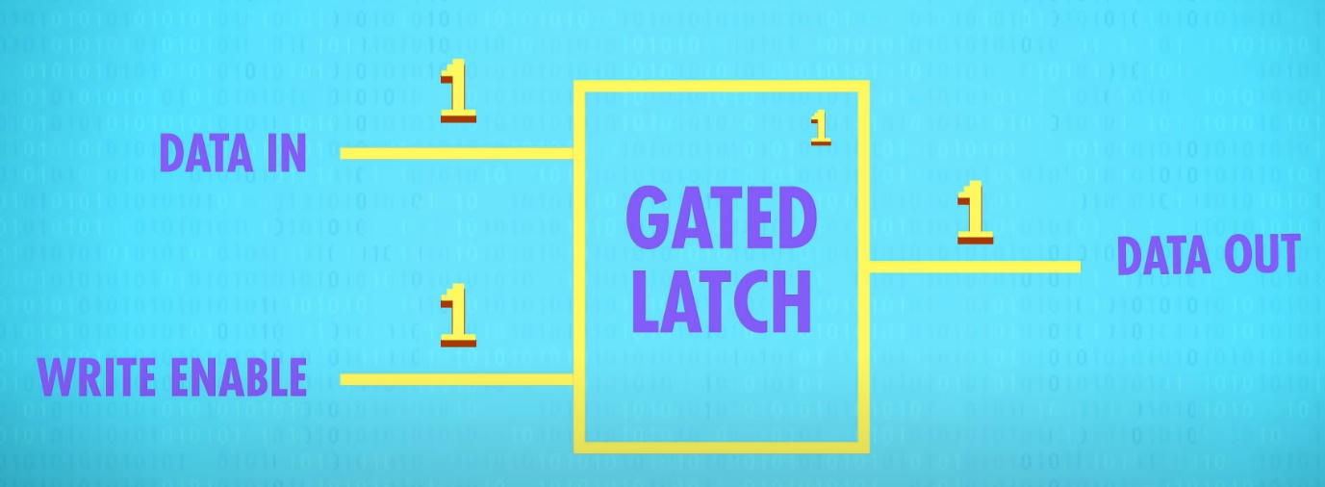Here the Write Enable Wire is On so data can be written, hence the data out is 1
* If Write Enable Wire is off, you can change Data in as much as you want and data out will remain the same
* In the example, this latch only stores 1 bit which is not very useful
* A group of latches operating like this is called a register, which holds a single number and the number of bits in a register is called its width
* Many registers today are 64 bits wide

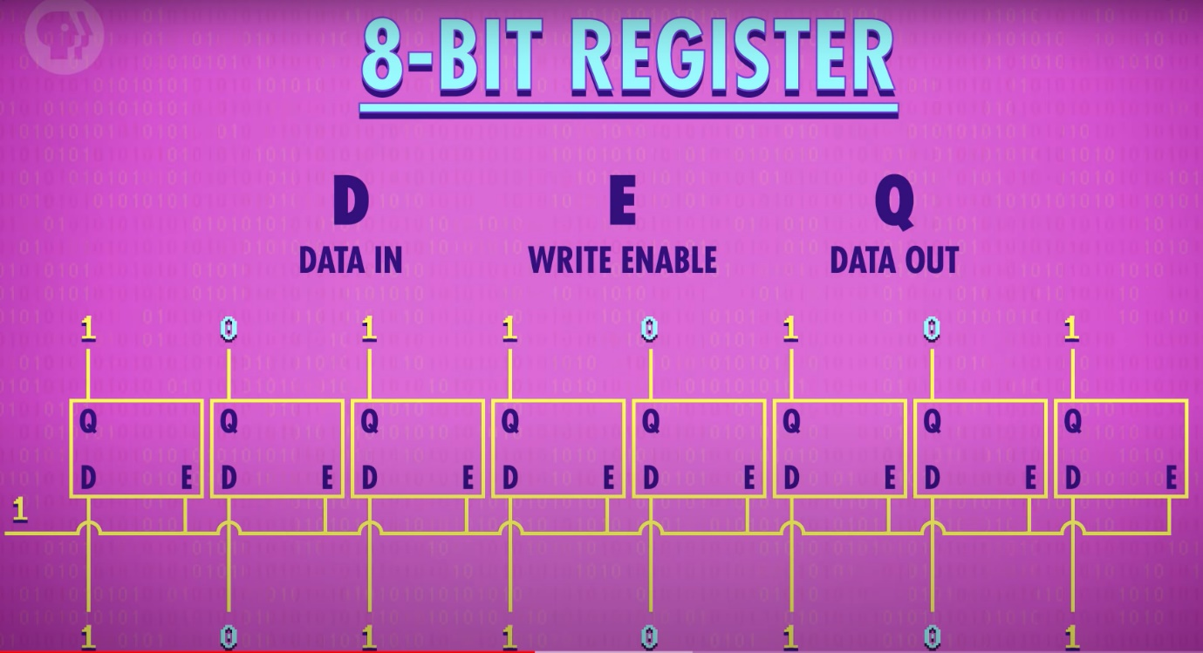

* First you set all the latch’s to true through a wire (Write Enable wire)
* You then put the data in
* You then turn off the Write Enable wire, and then Data out can be read
* 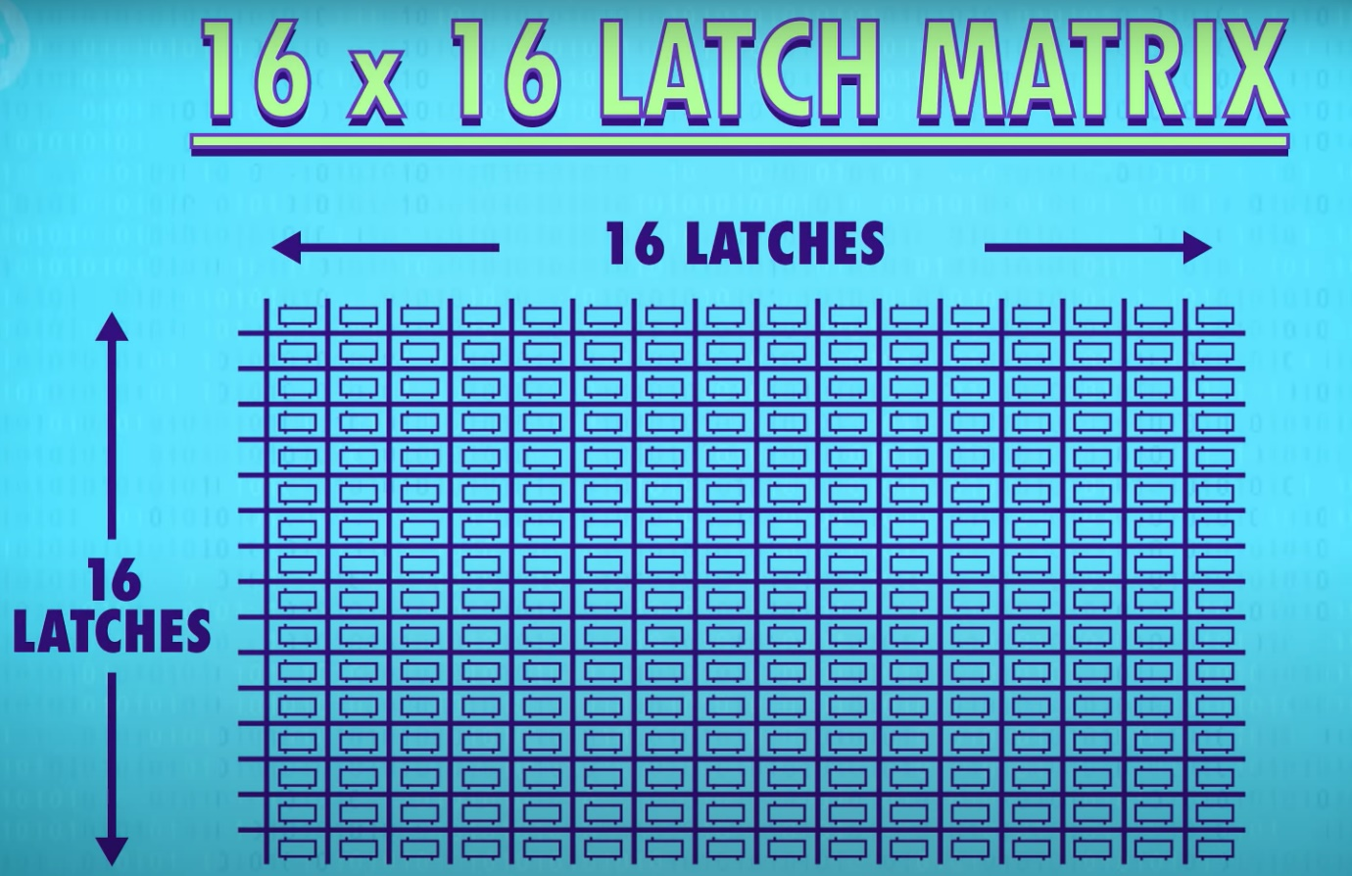To save on wires, Latches are added in a Latch Matrix e.g. for 256 bits
* 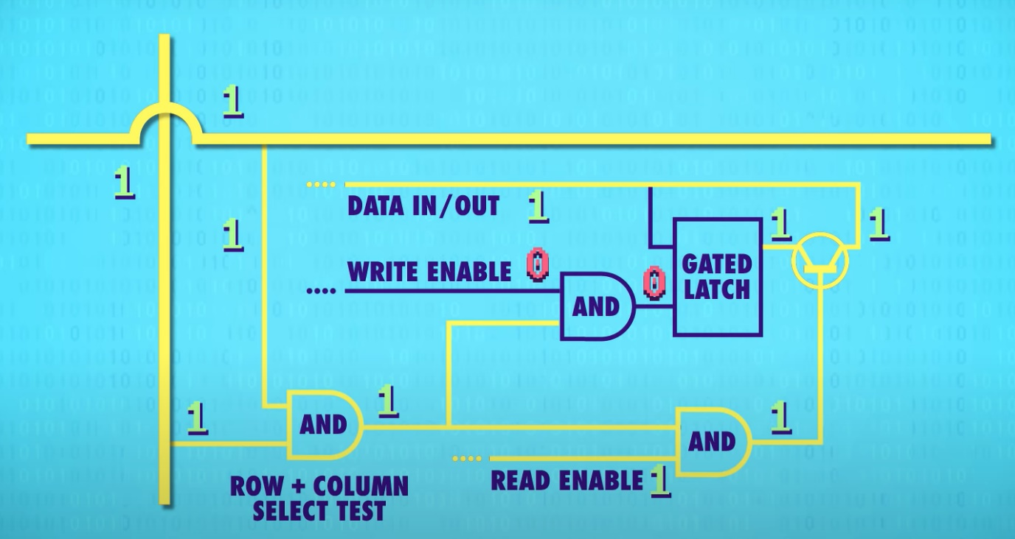To activate a latch, you need to turn on the corresponding row and wire. You only want the activate the latch at the intersection, other wires should be disabled, we use an AND gate
* In total for 256 bits, we only need 35 wires
  + 1 Data Wire
  + 1 Write Enable Wire
  + 1 Read Enable wire
  + 16 row wires and 16 column wires
* To specify each intersection, we have Memory Addresses
* A multiplexer converts an address to find a latch

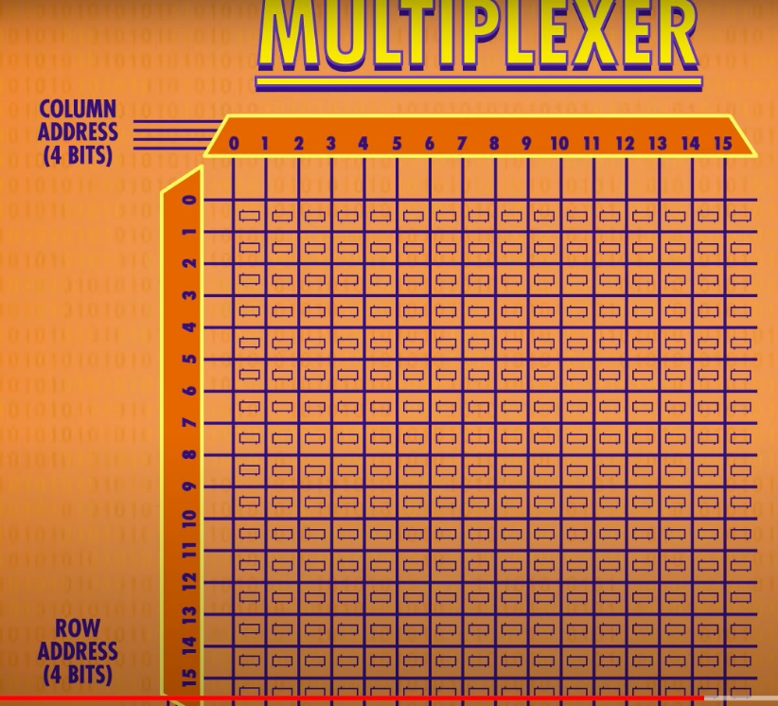E.g. if you input 1100100, the first 4 bits represent row 12 and next 4 bits represent column 8

Each latch holds a bit so we have 16 x 16 bits which is 256

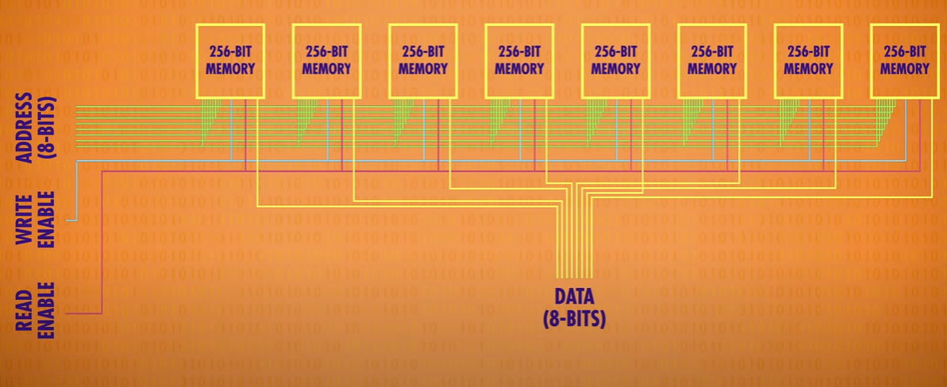

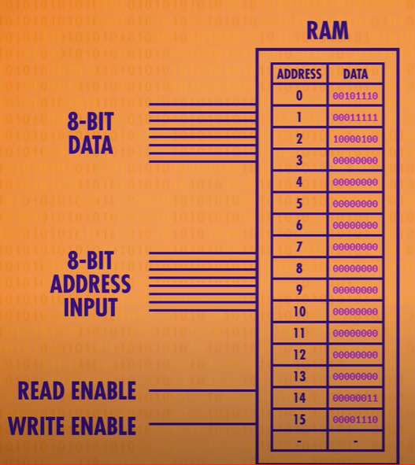

* RAM (Random Access Memory) is short term memory
* Watch 10:15 (YouTube vid) for visual representation of RAM

The Central Processing Unit (CPU): Crash Course Computer Science #7

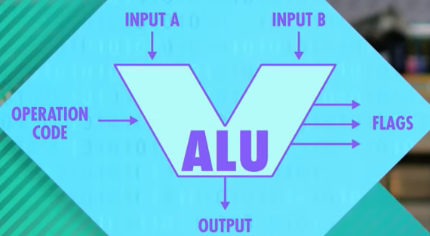

* CPU -> Central Processing Unit
* 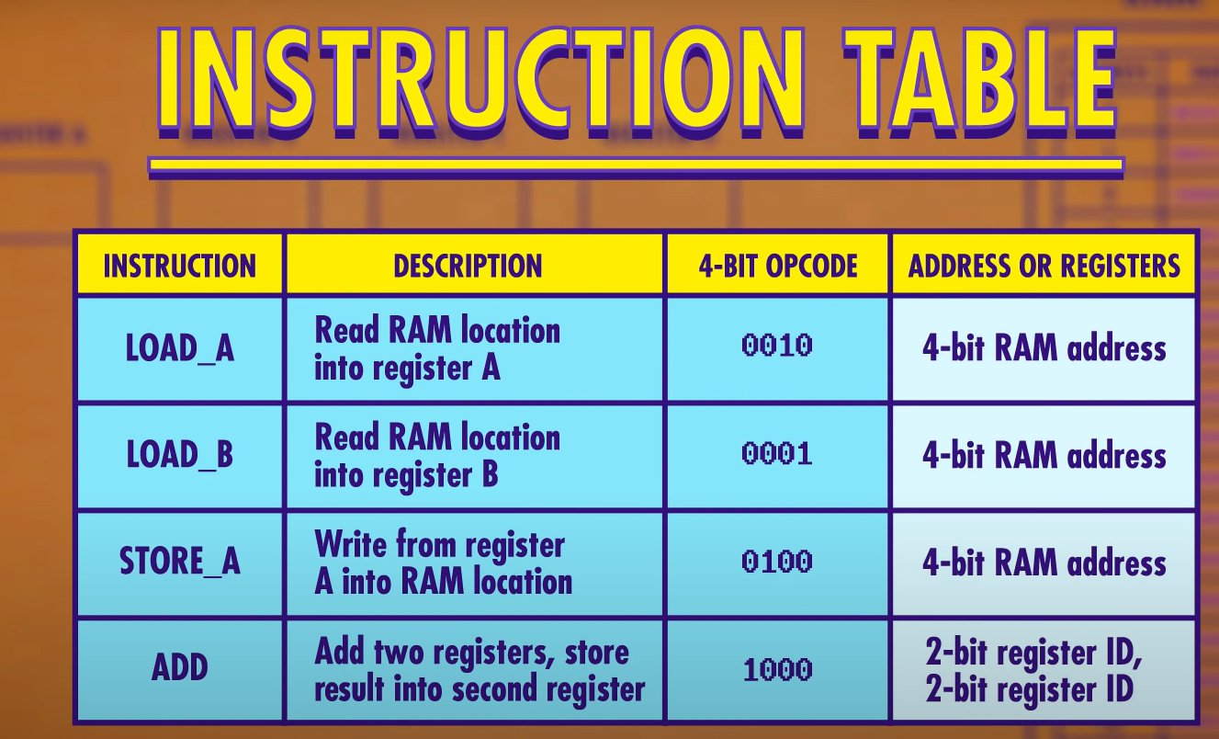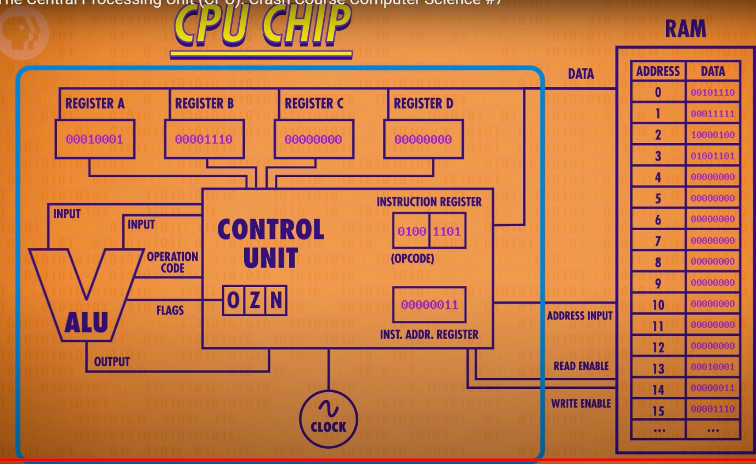A CPU’s job is to execute programs
* Watch video for Fetch Execute Cycle

This too: https://www.futurelearn.com/info/courses/how-computers-work/0/steps/49284

Instructions & Programs: Crash Course Computer Science #8

* Turing Machine -> Turing machines provided a simple yet powerful mathematical model of computation. Although using totally different mathematics, they were functionally equivalent to Lambda calculus in terms of their computational power.
* A Turing machine is a theoretical computing device equipped with an infinitely long memory tape (which stores symbols) and a read-write head which can read and write the symbols.

Turing machine which tells if even number of 1s:

* 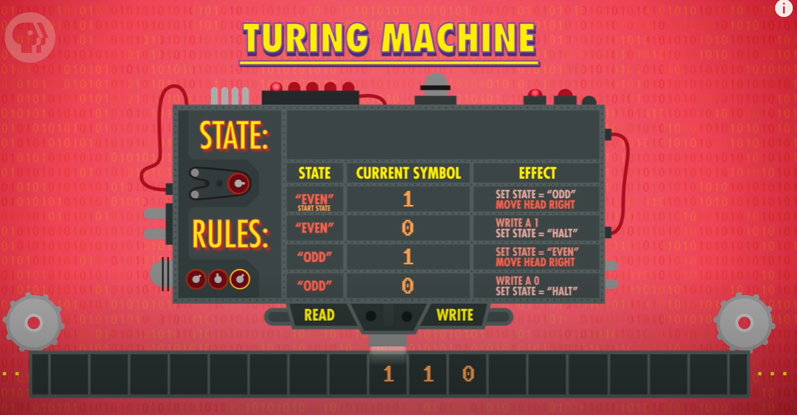Turing showed that this simple hypothetical machine can perform any computation if given enough time and memory. There is no computer more powerful than a Turing Machine. A computer that is as powerful as a Turing machine, is Turing complete.
* Halting problem-> is there an algorithm that can determine comma given a description of a Turing machine and the input from its tape, weather machine will run forever or halt? (Basically, will it occur forever?). A paradox says the halting problem can’t be solved with a Turing Machine.
* Alan Turing is the father of Artificial Intelligence
* Turing Test -> A computer would deserve to be called intelligent if it could deceive a human into believing that it was a human. (CAPTHA == Completely Automated Public Turing test to tell Computers and Humans Apart.)

Software Engineering: Crash Course Computer Science #16

* Programmers often use Object Oriented Techniques
* Programmers must use ‘Documentation’, this explains what each function in the code does, a well defined ‘Application Programming Interface’ or API
* Object Oriented Programming languages allow you to specify if a method is public or private, allowing the correct people to access the functions
* IDE -> Integrated Development Environment
* Read Me -> Help files
* Good documentation helps programmers when they revisit code they haven't seen for a while, but it's also crucial for programmers who are totally new to it.
* Source Control a.k.a version control, programmer can check out code, edit it and add new features, then commit code for everyone to use.
* Source control keeps track of all changes, so you can be roll back changes.
* Debugging goes hand in hand with writing the code, and it's most often done by an individual or small team.
* Quality assurance testing -> A team rigorously tests a piece of software attempting to create unforeseen consequences.
* Beta software -> software completed but not tested for bugs.
* Alpha software -> very buggy, only tested internally

Integrated Circuits & Moore’s Law: Crash Course Computer Science #17

* ICs -> Integrated circuits, these replaced discrete components
* Printed Circuit Boards -> metal wires already included to attach components together, these can be mass manufactured (smaller, cheaper, and more reliable)
* Photolithography -> Using light to transfer complex patterns to a material, like a semiconductor (used to create circuits)
* Moore’s Law -> Approximately every two years, thanks to advances in materials and manufacturing, you could fit twice the number of transistors into the same amount of space.
* The smaller the transistor, the less charge you have to move around allowing it to switch states faster and consume less power
* Starting in the 1970s, very large scale integration, or VLSI software, has been used to automatically generate chip designs instead.

Operating Systems: Crash Course Computer Science #18

* Operating Systems allow batch processing
* Interfacing with early peripherals was very low level, requiring programmers to know Internet hardware details about each device. On top of that, programmers rarely had access to every model of a peripheral to test their code on.
* OS is an intermediary between software programs and hardware peripherals (they provided a software abstraction through APIs called device drivers)
* OS allows multitasking, but at a cost of each program requiring its own memory. An OS allocates accordingly if it sees fit for a program to get more memory (may perhaps give no sequential memory).
* To avoid confusion if a program has dozens of blocks of memory scattered everywhere, it will cause confusion of programs to keep track of. To hide this complexity, operating systems virtualize memory locations (Virtual Memory). With virtual memory, programs can assume their memory starts at 0 despite this physically not being the case.
* This mechanism allows programmes to have a flexible memory sizes, called dynamic memory allocation, that appeared to be continuous to them. It simplifies everything and offers tremendous flexibility to the operating system in running multiple programmes simultaneously.
* 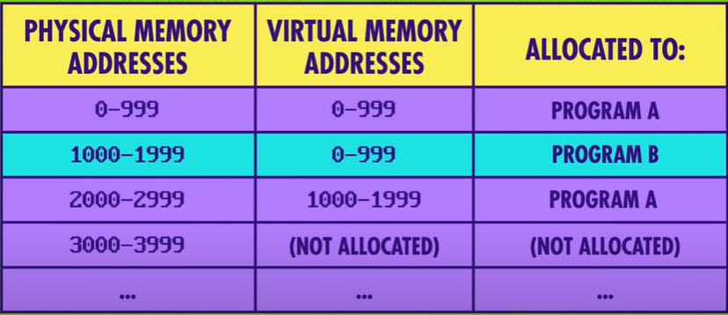Another benefit of giving each program its own memory, is that if a program bugs, it can only trash its own memory (memory protection).
* An early OS made was Unix, it was split into 2 parts:
  + First part was the Kernel, core functionality like memory management, multitasking and dealing with I/O
  + Second part was useful tools which came the kernel but not part of it, like programs and libraries
* Common OSs are Mac OS, Windows, Linux, Android, iOS

Memory & Storage: Crash Course Computer Science #19

* Memory is volatile, Storage is not volatile.
* The first type of memory was delay line memory which used pressure waves travelling from a speaker, reaching a microphone. This was sequential memory/ cyclic access memory so to access a particular bit you would have to wait for the whole loop. This isn’t that helpful; we need Random Access Memory.
* 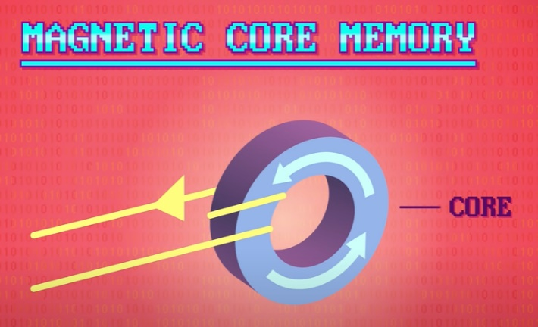Delay line memory was soon replaced by magnetic core memory. Here we put a wire around a magnet called a core. By turning on the current we can magnetize and polarize. The polarity represents 1 or 0 .

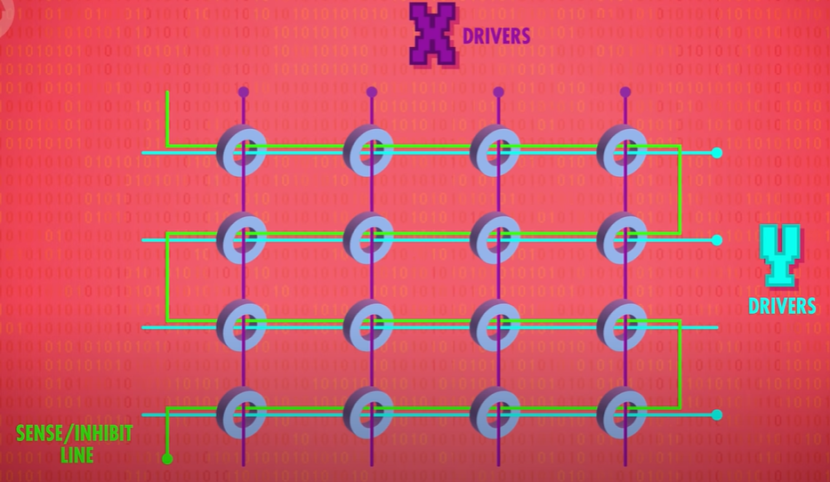

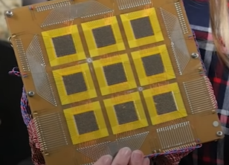

* We have wires running through each core, used to read/write a bit
* Here is a piece of core memory, each black square is 32x32 cores so 1024 bits, in total there is 9 squares so 1024 * 9 = 9216 bits which is 9 kilobytes.
* Furthermore, Tape Drives were made:

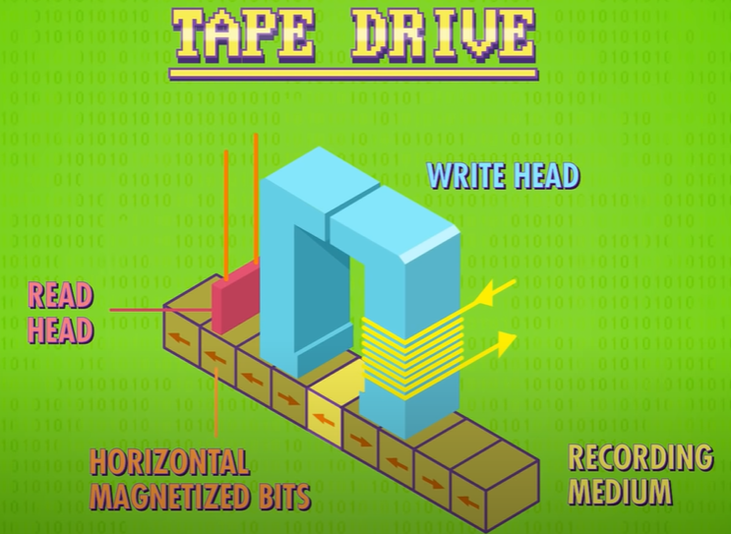

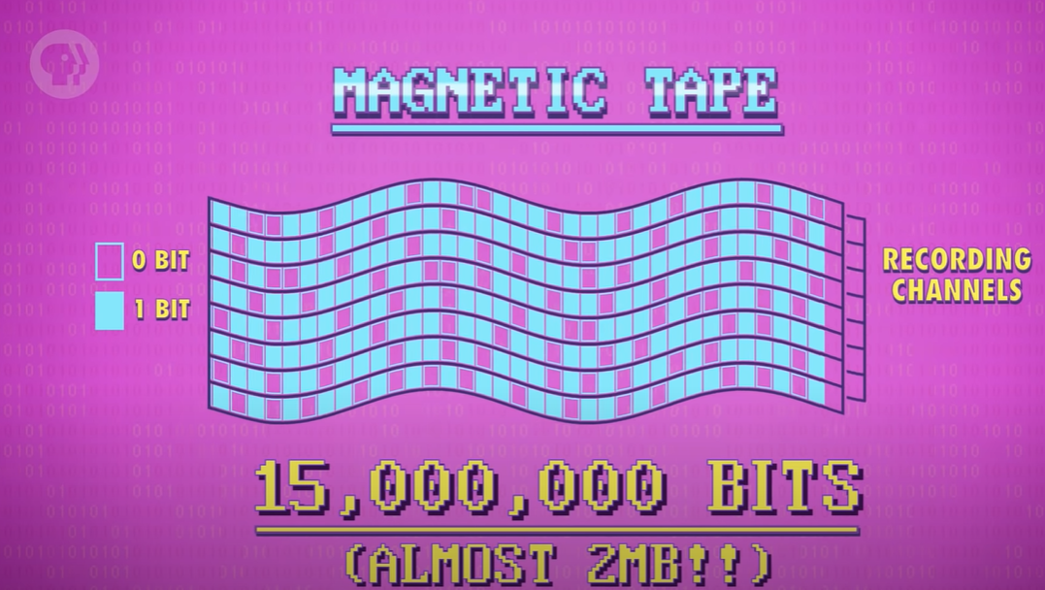

* Hard Disk Drives -> Surface of Disk is magnetic, allowing read/write head to retrieve data. Disks are thin so lots can be stacked together as lot of surface area for data storage.
* Seek Time-> Time it takes to access a block of data
* 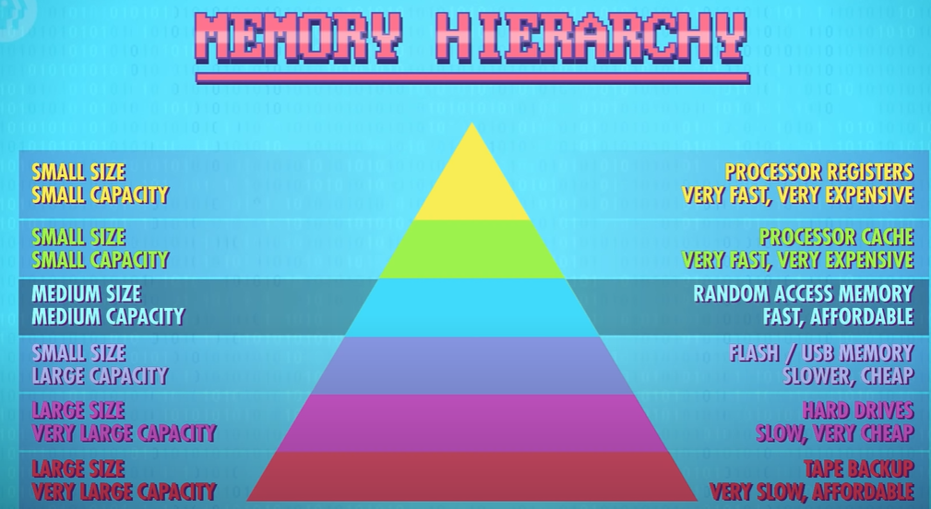Floppy Disk -> Like a hard disk but uses magnetic medium which is floppy
* CD (Compact Disk) -> Like Hard Disk & Floppy Disk but optical disks have little physical divots in their surface that cause light to be reflected differently, which is captured by an optical sensor and decoded into 1s and 0s.
* Solid State Drives (SSD) -> Contains no moving parts which contains parts from episode 15. Because they contain no moving parts, they don’t have to seek anywhere so SSD access times are 1/1000 second, but still a lot slower than RAM.

Files & File Systems: Crash Course Computer Science #20

* Files -> Big blocks of data
* File Formats -> e.g. .txt, JPEG, MP3, MP4 etc. Raw text files are just binary. A file format is useful as it tells the computer how to read it, e.g. a TXT file used ASCII.
* Before we can correctly read the data, we need to know some information, like the bit rate and whether it's a single track or stereo. Data, about data, is called metadata.
* 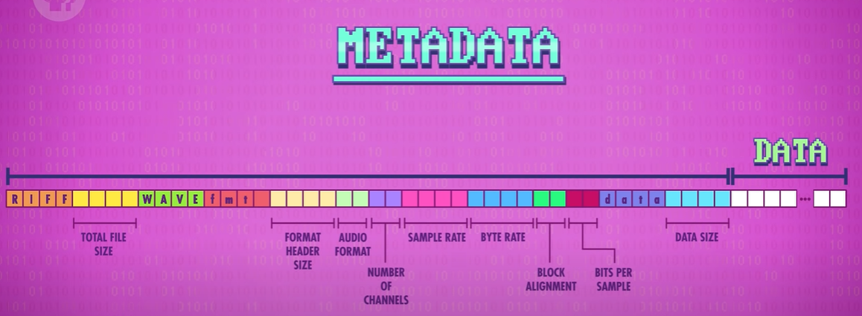Metadata is stored in the header of a sound file:
* 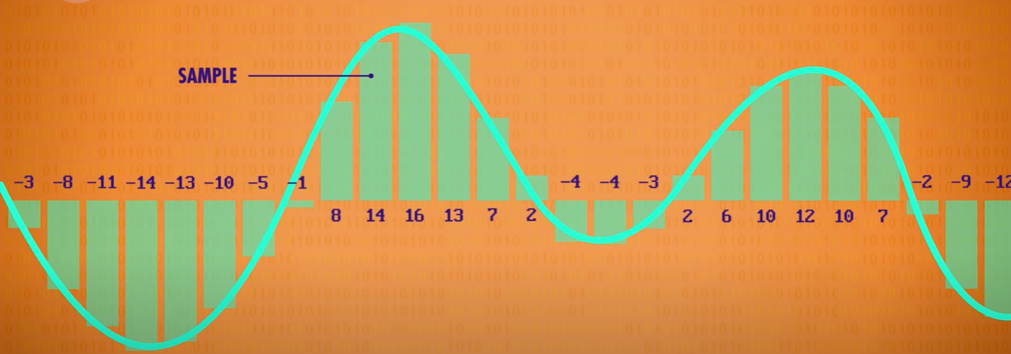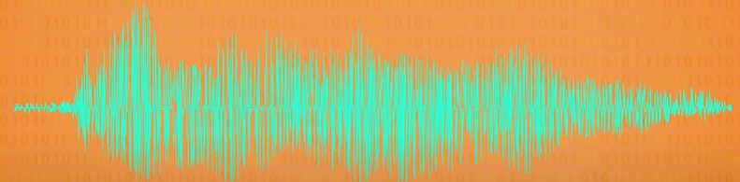E.g. Lets say “Hello” to a microphone:

These values are stored into the audio file

* In a computer, pictures are stored as pixels. Each pixel is a combination of three colours: red, green and blue period these are called additive primary colours, and they can be mixed together to create any other colour on our electronic displays.
* 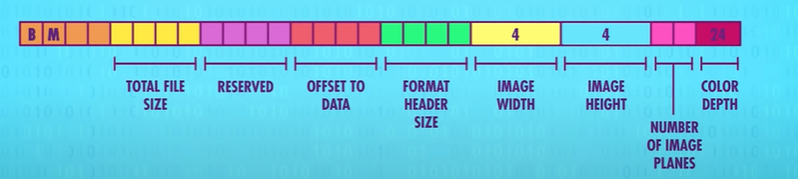Metadata for bitmap:
* Colour depth is 24 bits or 2 (8 bits each for Red, Green and Blue)
* 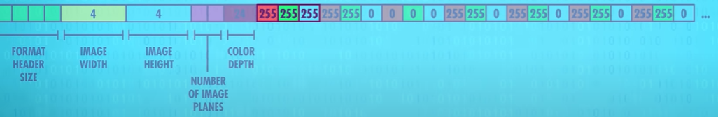The first pixel has red intensity is 255, second intensity is 255 and third intensity is 255. All in all, the first pixel is therefore white.
* The second pixel has 255 intensity red, 255 intensity green and 0 intensity blue, forming a yellow pixel.
* Files are stored next to each other, but how do we know when a file ends? We need a directory file, kept at the start (location 0). The directory contains all the files and metadata of the files (when created, last modified, if can be read/written)
* If anything to do with a file is modified, the directory file needs to be modified accordingly
* Modern file systems store files in blocks. To avoid overwriting neighbour blocks, file systems allocate an unused block so you can have files with variable sizes.
* 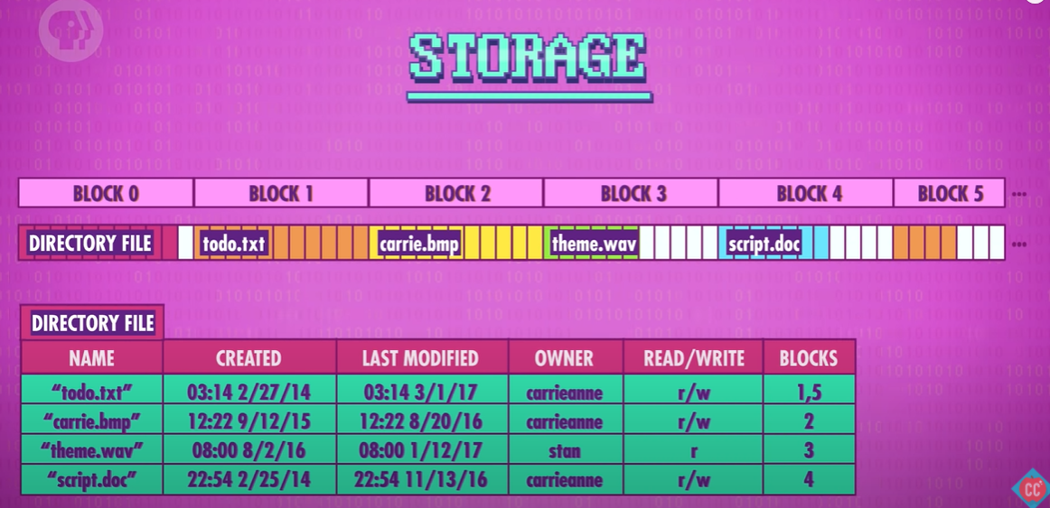If you delete an item, it will just be removed from the directory file, but it will remain until the block is overwritten by another file. So this enables forensic teams to access files which the user may have believed had been deleted.
* Files broken up in storage is called ‘Fragmentation’, the computer can perform ‘Defragmentation’ to move blocks around accordingly.
* 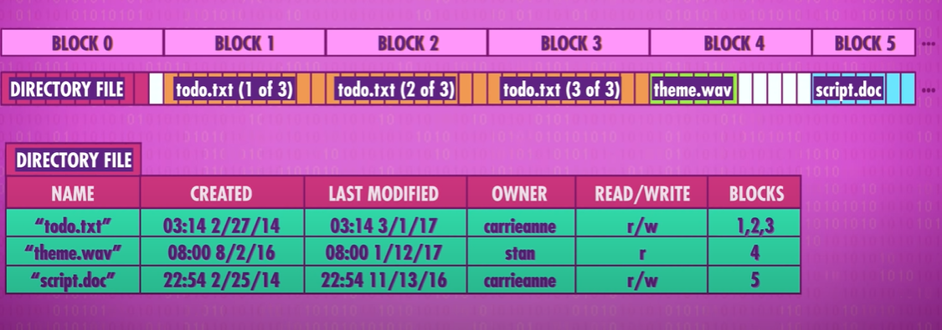The root directory is the top-most directory. All other files and folders lie beneath this directory along various file paths.

Compression: Crash Course Computer Science #21

* 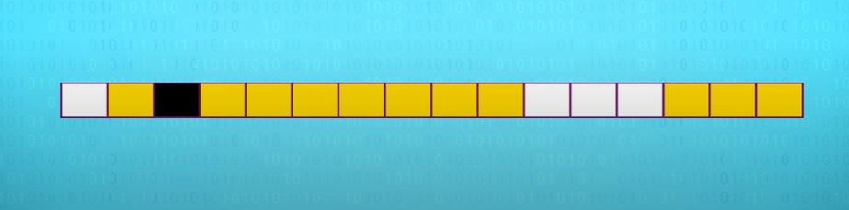Compression is the method computers use to make files smaller by reducing the number of bits (1's and 0's) used to store the information.
* The above is the actual representation of an image. Meta data is used to say when each row ends.
* 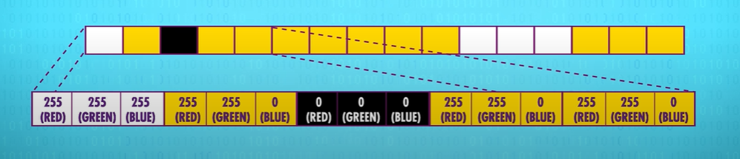We have 4*4 so 16*3 bytes of information (48 bytes). We can compress the data into a smaller number of bytes, we can do this using run-length encoding. This takes advantage of the fact that there are identical runs of data in a file. E.g.
* 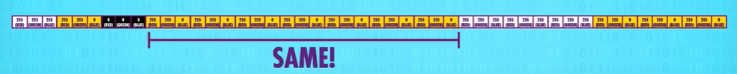We can replace with this:
* 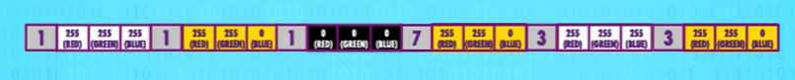In some cases, adding these prefixes adds to the data but on the whole, it reduces it
* A compression technique that has this characteristic is called lossless compression because we don't lose anything. The decompressed data is identical to the original before compression, bit for bit.

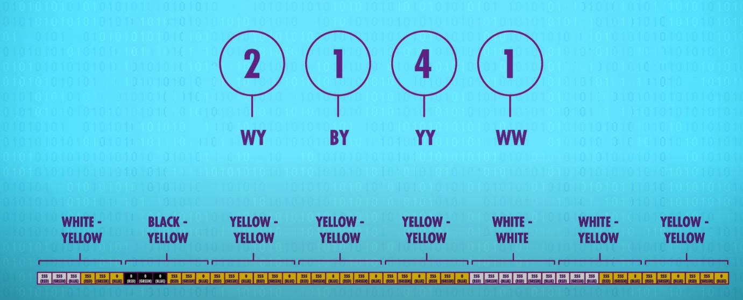

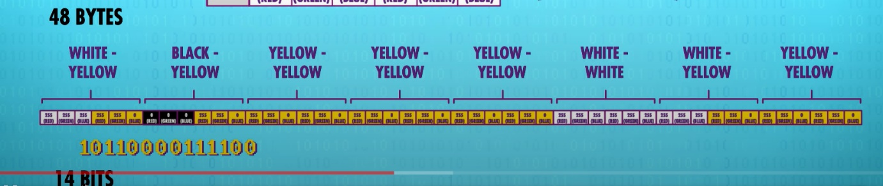We can put this into a Huffman tree (watch 4:44 for Huffman tree demo) which has the property of putting less frequent items at the bottom.

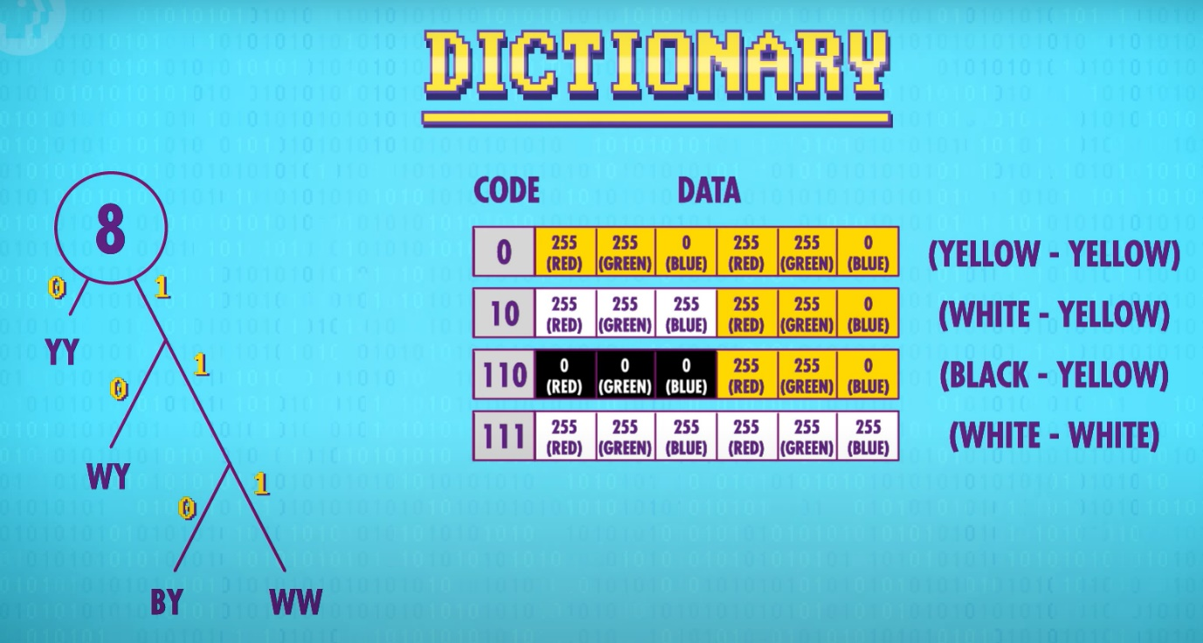

* We now have 30 bytes, significantly less than 48 bytes
* Both run-length encoding and dictionary coders are lossless compression techniques. No information is lost; when you decompress, you can get the original file.
* Lossy compression techniques-> removing less important information, removing things which human perception is not good at identifying.
* For example, if we are recording sound, we can remove sound which has the ultrasonic frequency as humans can’t here this. We preserve the human vocal range. Lossy audio compressors take advantage of this, and encode different frequency bands at different precisions. As signal quality of bandwidth worsens, compression algorithms remove more data.
* JPED (Joint photographic experts group) -> breaks images to 8*8 pixels
* This maintains the visual essence but may only use 10% of the data
* Similarly, videos are just a collection of images which too can be compressed. Videos can also use temporal redundancy, which copies patches of pixels forward. When there are pixel differences, most video formats just send this patch difference forward.

Keyboards & Command Line Interfaces: Crash Course Computer Science #22

* In early times, it's important to recognise that computer input of this era was designed to be as simple and robust as possible for computers. Ease and understanding for users were a secondary concern.
* Command Line Interfaces-> user can type commands and receive feedback
* cd -> change directory
* ls -> list

Screens & 2D Graphics: Crash Course Computer Science #23

* First screens used Cathode Ray Tubes which show electrons using an electron gun at phosphor coating screen, the charge electron’s path is steered using coils
* LCD -> Liquid Crystal Display, uses pixel which uses raster scanning on pixels
* Character generators-> first graphic cards, these has ROM (Read Only Memory)
* Computer-Aided Design was a huge milestone for screens, designing sketches on a computer screen
* Bits in memory directly “mapped” to pixels on the screen, what are called bitmapped displays. With full pixel control, totally arbitrary graphics were possible.

The Cold War and Consumerism: Crash Course Computer Science #24

* UNIVAC I -> First commercially successful computer
* Apollo guidance computer -> NASA needed a computer to process complex trajectories and issue guidance commands to the spacecraft. This had to be fast, it had to be small and lightweight, and had to be very reliable.
* The Japanese were the first to invent the handheld electronic calculators, using integrated circuits and this led to the development of microprocessors

The Personal Computer Revolution: Crash Course Computer Science #25

* By the 1970s it was possible to create low-cost personal computers, microcomputers
* This was done using machine code so was very difficult to use, Bill Gates and Paul Allen contacted the manufacturer and recommended for it to be written in Basic (popular and simple programming language). To do this they needed to write a programme which converted basic instructions into machine code, using an interpreter (this is like a compiler but happens in run time).
* Steve Wozniak and Steve Jobs created Apple I (required users to solder and create, businesses were not interested). They then created Apple II which was professionally designed and manufactured, this could be used by businesses.

Graphical User Interfaces: Crash Course Computer Science #26

* The Macintosh was the first PC with a GUI and mouse to interact with, a revolution since the command line interface (point and click interface)
* Desktop -> The idea that e.g., a load of paper can be put on a desk, a PC should be intuitive and allow users to use multiple programs at once, each has its own view as a window
* Mac competed with Windows 95 (first release of Windows OS)

3D Graphics: Crash Course Computer Science #27

* Wireframe rendering -> Converting 3D shape to 2D
* 3D shapes can be made with polygons, the more polygons, the most accurate the curves of the shape but this results in more work for the computer
* Game designers must carefully balance model fidelity versus Polygon count, because if the count goes too high, the frame rate of an animation and drops below what users perceive as smooth. For this reason, there are algorithms for simplifying meshes.
* Wireframe rendering is achieved using scanline rendering
* 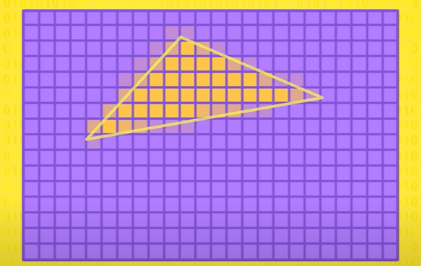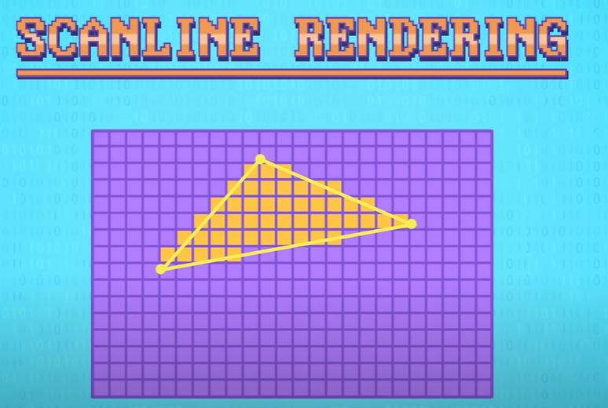This however has rough edges, to soften this effect we use anti-aliasing.
* Occlusion is when some polygons are in front of others
  + 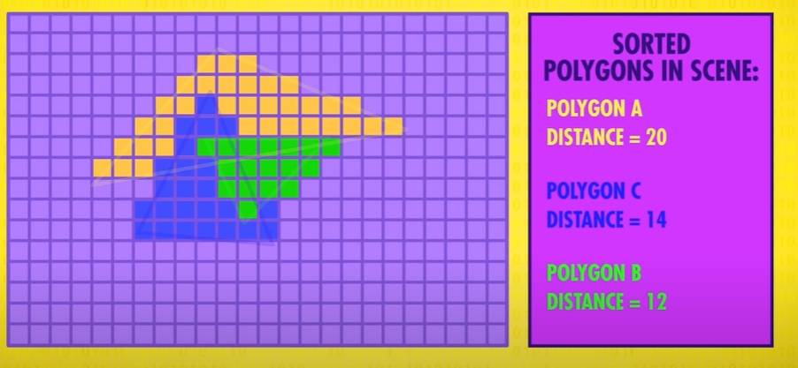We can use the painters algorithm to do this, where we arrange by distance and render in that order (needs sorting first for distance):
  + Alternatively, we can use z-buffering (same output, different algorithm), this method requires no sorting of distance. It just checks to distance of the polygon to its Z-buffer, it just records the lower of the 2 values. E.g. first for polygon A, it replaces all the values in the polygon as 20 is less than infinity. Then for polygon B, all the infinities and 20s in its path is replaced. Then for polygon C, all the infinities and 20s is replaced but not 12s as 14 is greater. If 2 polygons have same distance, it causes a conflict hence flickering in the e.g., game.

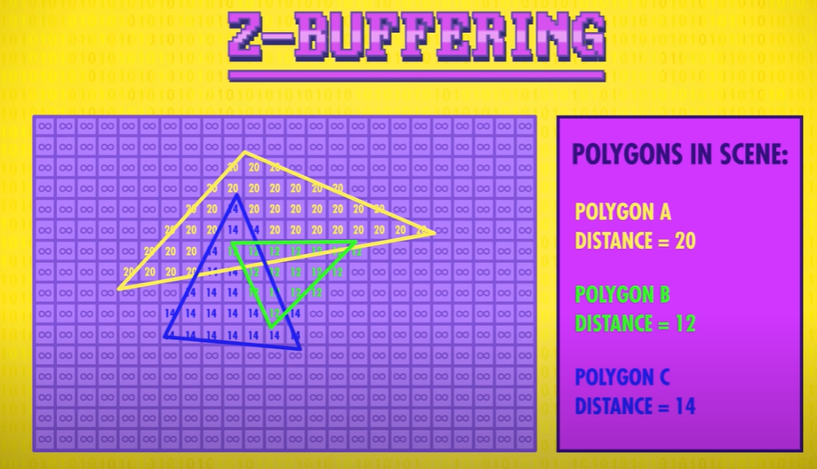

* Another optimisation in 3D rendering is back-face culling, e.g., a triangle has 2 sides, you should only see the front side. To save processing time, the back of the polygon is not shown in the rendering pipeline, reducing the number of polygon faces by half. This is when walls become invisible in games.

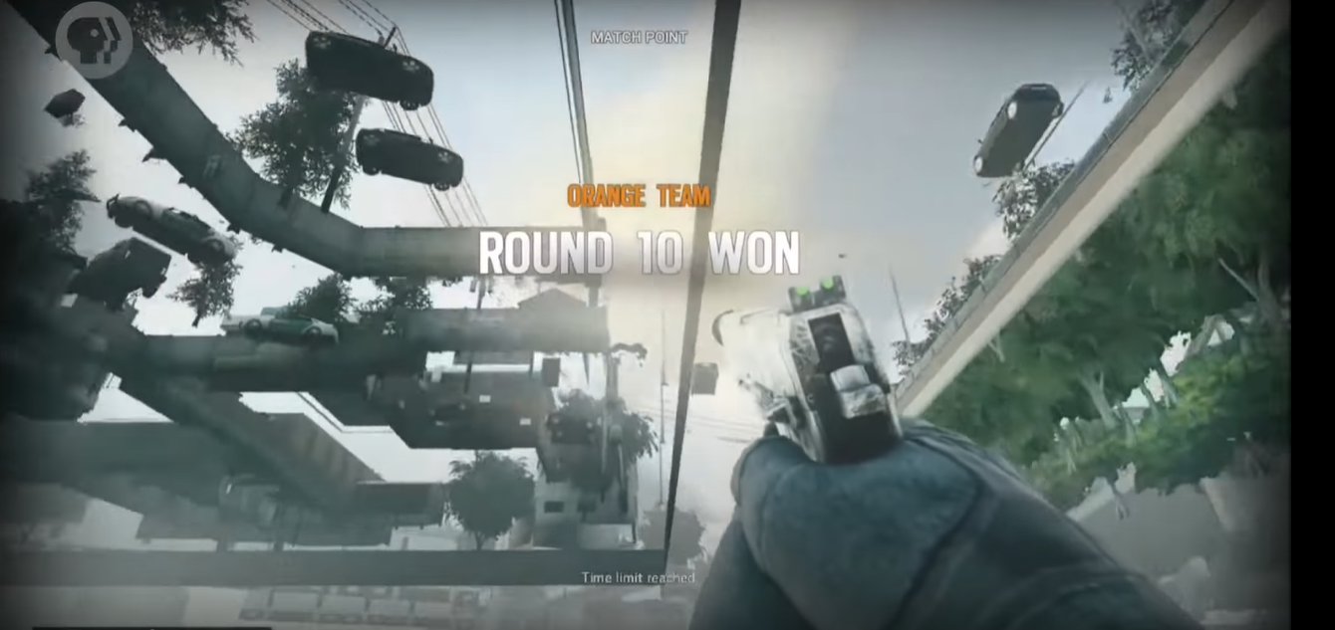

* Lighting a.k.a shading. We can pick a few polygons in our object and consider how the polygons are oriented in 3D space (no longer parallel to screen), this is the surface normal. The direction can then be compared to a light source, causing shading. Algorithms which exist for this include: Flat shading, Gouraud shading, Phong shading.
* Textures-> we can use texture mapping,

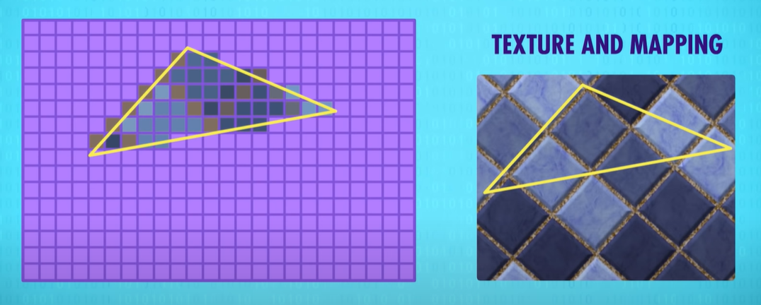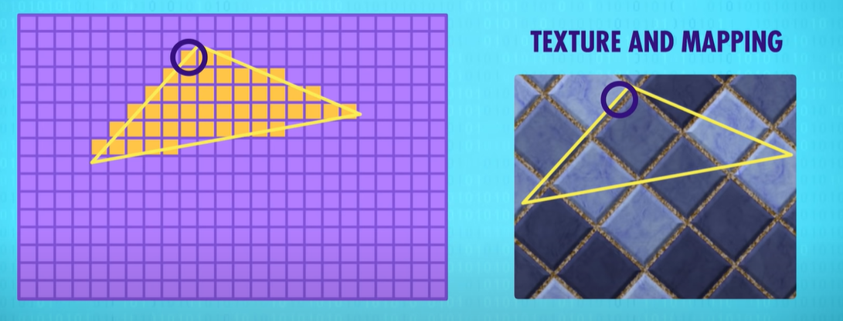

* Rendering a scene requires a lot of computation, but it is literally the same calculation being repeated for millions of polygons. To speed things up we can use:
  + CPUs aren’t designed for this so computer engineers created special processors for this, GPUs (graphics processing unit). This is where meshes and textures exist.
  + We can also divide 3D scenes into many smaller parts and render all pieces in parallel rather than sequentially.

Computer Networks: Crash Course Computer Science #28

* Latency -> the time it takes for a message to transfer
* LAN -> Local area networks, can be two computers in a room or a university network. Data can be sent through ethernet but because the cable is shared, every computer can see the transmission, to solve this problem we have MAC address
* MAC address (media access control), this is used as a header and prefixes any data sent over the network so computers can listen to this and process data if their MAC address is in the header
* The general term for this approach is ‘carrier sense multiple access’, or CSMA for short. The ‘carrier’, in this case, is any shared transmission medium that carries data – copper wire in the case of ethernet, and the air carrying radio waves for Wi-Fi. Many computers can simultaneously sense the carrier
* Bandwidth -> Rate at which carrier can send signals
* Unfortunately using a shared carrier of having a drawback of ‘collisions’ in which 2 computers attempt to write data at the same time and data messes up. To solve this, ethernet can have random wait times before information is received, if it collides again we keep doubling waiting times until successful (this is exponential backoff)
* 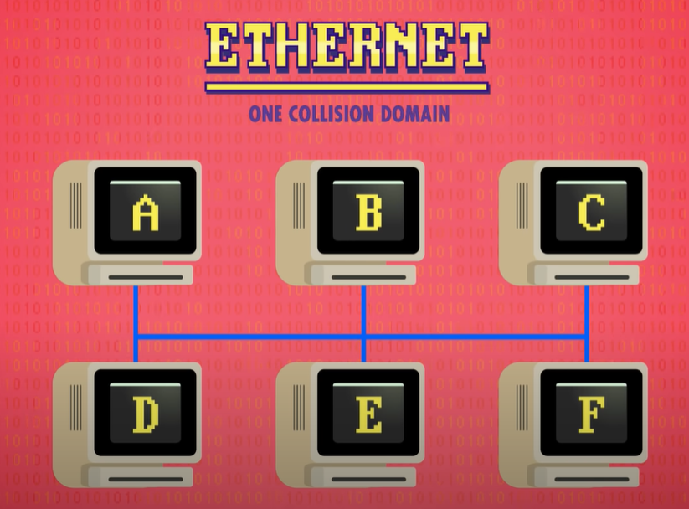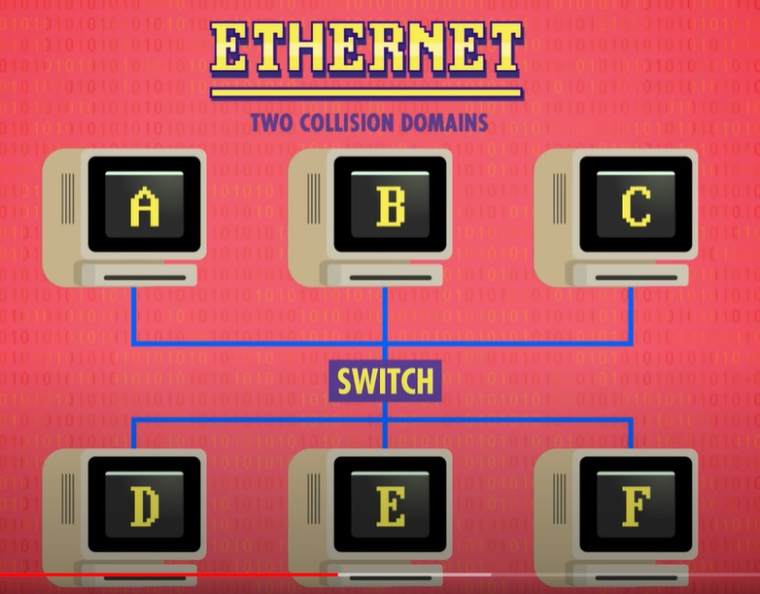To reduce collisions and improve efficiency we need to shrink the number of devices on any given carrier (collision domain)
* Data us only passed through the switch, if necessary, e.g., if A wants to transfer to C, the switch remains closed, this means if E wants to transfer to F, it can do so. If A wants to transfer to F, briefly the 2 networks are occupied.
* Circuit switching can be used in networking. It is when you switch whole circuits to route traffic to the correct destination. It works fine, but it’s relatively inflexible and expensive, because there’s often unused capacity. However, if you have a line to yourself, you can use it to its full capacity (military does this)
* Another approach of getting data one place to another is message switching, this is good because messaging can use alternative routes, so it is fault tolerant. The number of hops a message takes in its route is a hop count. Keeping this count is important as it helps identify routing problems. A message stores its hop count, if a message has high hop count it is likely something has gone wrong, the hop limit. A downside to message switching is it can clog the network. For the message to get through, it must either wait for the large message to get through or take a less efficient route. A solution is to split a message into packets. Just like with message switching, each packet contains a destination address on the network, so routers nowhere to forward them. This format is defined by the Internet Protocol, or IP for short, a standard created in the 1970s.
* IP address -> every computer connected to a network has an IP address.
* Congestion control -> Network routers are constantly trying to balance the load over the routes they know for speedy and reliable delivery.
* Sometimes packets from the same message take different routes through a network, this means that some packets can arrive at destination at a random order. Fortunately, protocols run on top of IP , TCP/IP to prevent this.
* Chopping up data into small packets, and passing these along flexible roots with spare capacity, is so efficient and fault tolerant, it's what the whole Internet runs on today. This routing approach is called packet switching. There is no single point of failure.

The Internet: Crash Course Computer Science #29

* Every device at home is connected to a LAN (wireless router), this then connects to a WAN (wide area network) which is run by your ISP (internet service provider)
* To request this video file from YouTube, a packet had to work its way up to the backbone, travel along that for a bit, and then work its way back down to a YouTube server that had the file. That might be four hops up, two hopes across the backbone, and four hops down, for a total of ten hops.
* Internet packets must abide by the Internet protocol. IP is very low-level protocol; it just contains a destination address and a packets header (metadata). This means a packet may show up to a computer, but a computer may not know which application to give it to. For this reason, another protocol sits on top of IP, the UDP protocol. UDP has its own header which is in data payload. Inside the UDP header is extra information, one example is a port number.
* 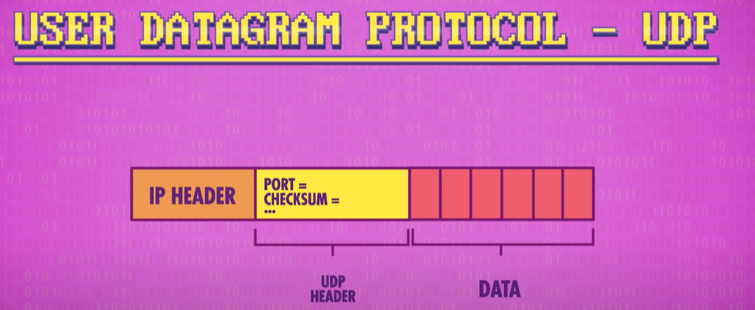Every program wanting to access the internet will ask its host computer’s operating system to be given a unique port. E.g., Skype might ask for port number 3478. When a packet arrives to the computer, the operating system will look inside the UDP header and read the port number, then if it sees e.g., 3478, it will give the packet to Skype.
* Summary -> IP gets the packet to the right computer, but UDP gets the packet to the right program running on that computer.
* The UDP header also contains checksum, which checks the data for correctness by checking the sum of the data
* For example, before the packet is sent the transmitting computer calculates the checksum by adding all the data together. The UDP only holds 16 bits so if the checksum is larger than this, an overflow occurs and the first 16 bits are used.
* 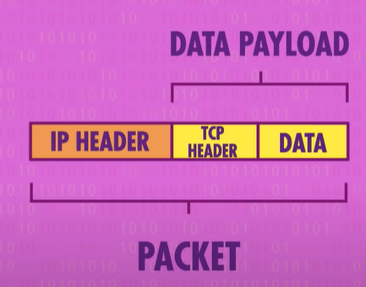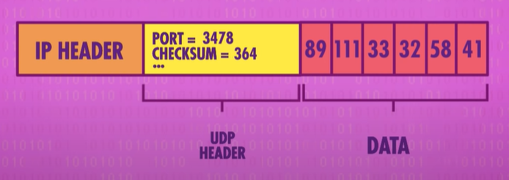When the receiving computer gets this packet, it repeats the process with the check sum and compares it. If the sum is the same, all good, if not then the data got corrupted by e.g., power cut. Unfortunately, UDP doesn’t offer any mechanisms to fix the data, or request a new copy – receiving programs are altered to the corruption, but typically just discard the packet. This is why sometimes Skype glitches, only a few of the packets show up on the receiver end. This approach wouldn’t work for programs like emails though, for this you absolutely need all the packets so the full email can be sent. For cases where it NEEDs to get there, programs use Transmission Control Protocol. This, like UDP, rides inside the data payload of IP packets (this is why people refer to it as TCP/IP)
* 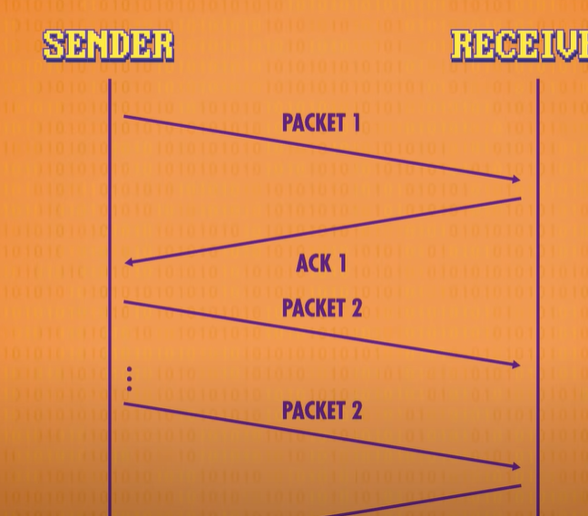Like UDP, TCP has a destination port and checksum but also contains fancier features e.g. sequential numbers for packets (these allow packets to be received in correct order, even if they arrive at different times in network). TCP also sends an acknowledgement that packet made it successfully, then send the next packet. If packet hasn’t been confirmed after a while, it is resent.

It's possible that the original packet could have been reached, just that the acknowledgement is very delayed or lost. A duplicate packet can also be discarded.

* Also, TCP isn’t limited to a back and forth conversation – it can send many packets and have many outstanding acks (acknowledged). This increases bandwidth significantly as you are not waiting for acknowledgement packets to return.

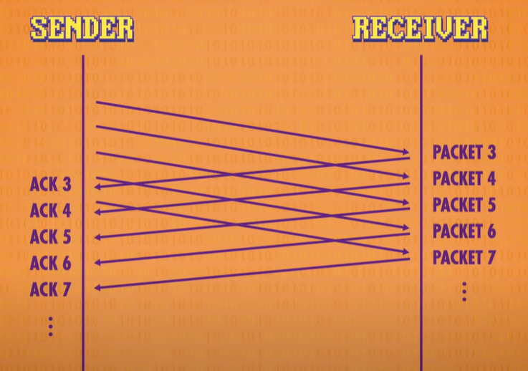

* Also, the success rate of ACKs and round trip time between sending and acknowledging can be used to infer network congestion and adjust how aggressively it sends packets (throttling transmission depending on the bandwidth)
* People may use UDP over TCP because with TCP you are doubling the number of messages on the network and you’re not transmitting any more data.
* When your computer wants to make a connection to a website, you need 2 things: an IP address and port e.g. IP address: 172.217.7.238 and port : 80 (this is the IP address and port for the google webserver, type this URL in ‘172.217.7.238:80’)
* Typing the IP address works but remembering the numbers is hard, its easier to remember google.com so the internet has a special service that maps these domain names to addresses-> Domain Name System (DNS), it’s like a phonebook
* 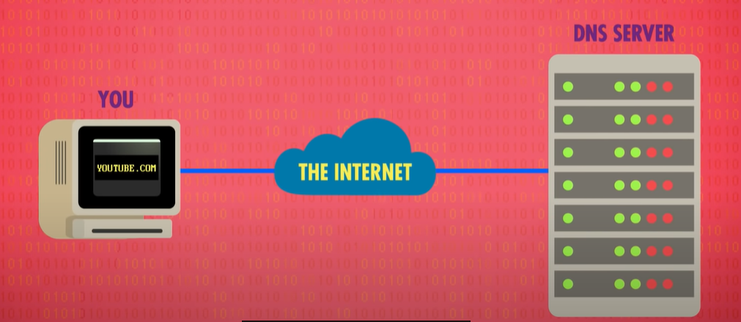When you type something like youtube.com into your web browser, it goes and asks a DNS server (provided by ISP), the DNS consults its huge registry and replies with an address if one exists.
* To avoid searching a huge list, a tree structure is used for searching.
* 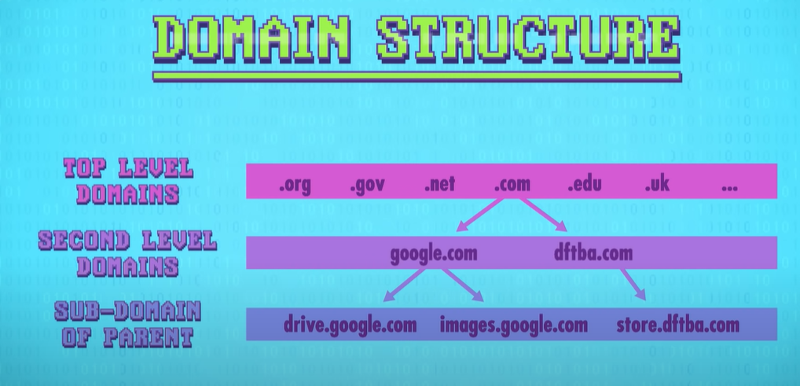Physical layer -> Electrical signals in wires or radio signals in air (wireless networks)
* Data Link Layer -> MAC addresses, collision detection, exponential backoff and similar low level protocols that mediate access to the physical layer
* Network layer -> Where all the switching and routing technologies operate
* Transport layer -> UDP and TCP
* Session layer -> Where protocols like TCP and UDP open a connection, pass info back and forth and then close the connection when finished

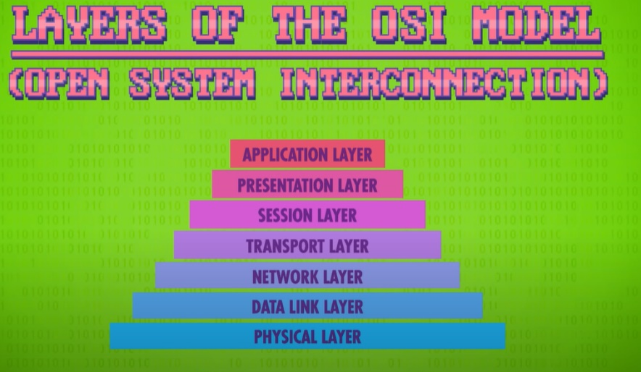

The World Wide Web: Crash Course Computer Science #30

* The World Wide Web is not the same thing as the Internet, even though people use it interchangeably . The world wide web runs on top of the internet, like Facebook, Skype etc. It too is an application, accessed using a special program: web browser.
* Hyperlinks -> content of other webpages, help to form a huge web of interconnected information
* Hypertext-> texts containing hyperlinks
* URL (uniform resource locator) -> for pages to link to one another each hypertext needs a unique address (URL)
* Steps for loading a page: URL -> DNS server -> returns IP address, setting up a TCP connection with a webserver with URL’s website -> HTTP (hypertext transfer protocol), replies with hypertext which is rendered by web browser
* HTML (Hypertext markup language) -> used for web browsers distinguishing between text and hyperlinks
* Web browsers -> render and request media
* Search Engine -> a program that searches for and identifies items in a database that correspond to keywords or characters specified by the user, used especially for finding sites on the World Wide Web.
* Net neutrality -> in short, network neutrality is the principle that all packets on the Internet should be treated equally. It doesn't matter if the packets are my email or you streaming this video, they should all took along the same speed and priority.

Cybersecurity: Crash Course Computer Science #31

* Secrecy or confidentiality, means that only authorised people should be able to access or read specific computer systems and data
* Integrity means that only authorised people should have the ability to use or modify systems and data
* Availability means that authorised people should always have access to their systems and data e.g., Denial of Service attack
* Security experts start of with a specification of who enemy is (threat model) -> profiles attackers (attack vector)
* Authentication is the process by which a computer understands who it's interacting with
* A brute force attack is one which attempts every possible combination
* Deterministic -> Always producing the same predictable result from given input
* Two factor/ multi-factor authentication -> An attacker may be able to guess your password or steal your phone: but it’s much harder to do both.
* Access control -> this is done through permissions or Access Control Lists (ACL), which describe what access each user has for every file, folder and program on a computer.
  + Read -> allows a user to see the contents of a file
  + Write -> allows a user to modify the contents
  + Execute -> allows a user to run the file
* Malware -> compromising a host’s operating system

Hackers & Cyber Attacks: Crash Course Computer Science #32

* Social Engineering -> where a person is manipulated into divulging confidential information or configuring a computer system, so it permits entry by attackers e.g. Phishing (clones)
* Pretexting -> Attackers call up a company pretending to be a part of the IT department getting them to reveal confidential passwords
* Trojan horses -> programs that masquerade as harmless attachments e.g. photos or invoice, but contain malicious software (malware)
* Exploit -> Successfully utilizing a bug to gain capabilities or access e.g. buffer overflow (overwriting adjacent memory)
* To combat a buffer overflow, we can use bounds checking. Programs can also randomize the memory location of variables, so hackers don’t know which memory location to overwrite
* Programs can also include unused space and see if they change, if they do then they know an attacker is medalling around (these regions are called canaries)
* Code injection -> affects databases e.g. SQL injection
* Sanitize -> good servers also sanitize input by removing or modifying special characters before running database queries
* Worms -> jump from computer to computer
* Botnet -> if hackers can hack many computers, they can form a botnet. They can send large no of spam, mining bitcoin or using other people’s computing power, DDoS (distributed denial of service) attacks are where all of the computers in the botnet send a flood of dummy messages, This can knock services offline, either to force owners to pay a ransom or just to be evil.

Cryptography: Crash Course Computer Science #33

* Cryptography translated to secret writing
* Cipher -> An algorithm that converts plain text into cipher text
* Encryption makes text secret, the opposite is decryption
* Caesar Cipher -> a substitution cipher, a flaw is frequency analysis
* Enigma used a substitution cipher with many rotors

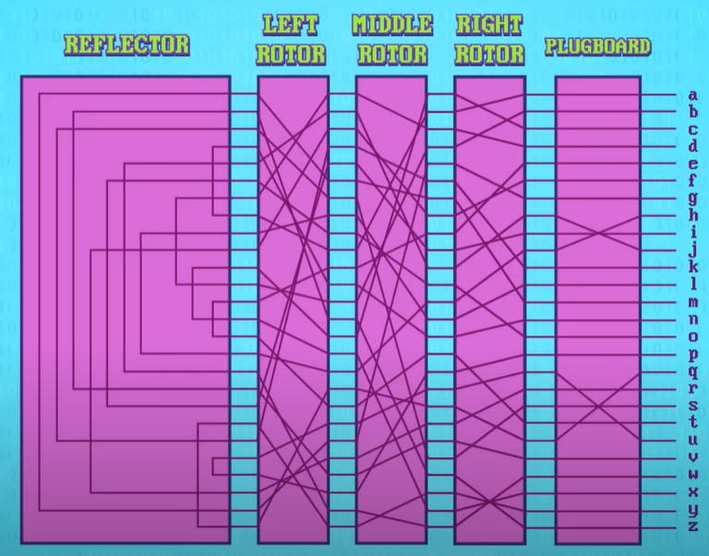

* The circuit flows both ways, so ‘h’ would give ‘l’ and ‘l’ would give ‘h’. No letter can be itself. To avoid Enigma being a simple substitution problem, every time a letter was pressed, the rotor would increment so e.g., ‘aaa’ would translate to ‘bdk’
* AES (advanced encryption standard) -> uses 128- or 256-bit keys, diminishing possible attacks by brute force. AES drops data into 16-byte blocks, and then applies a series of substitutions and permutations, based on their key value, plus some other operations to obscure the messages, and this process is repeated 10 or more times for each block.
* Key exchange -> an algorithm that lets 2 computers agree on a key without ever sending one (one-way functions -> easy to do in one direction, very difficult to go in opposite directions). We use Diffie-Hellman key exchange.
* Symmetric keys -> keys are same on both sides, asymmetric keys are opposite (asymmetric example is RSA)

Machine Learning & Artificial Intelligence: Crash Course Computer Science #34

* Machine learning -> Algorithms that give computers the ability to learn from data, and then make predictions and decisions
* Classification -> classifier algorithms, classify data into groups using features (Values that usefully characterize the things we wish to classify)
* 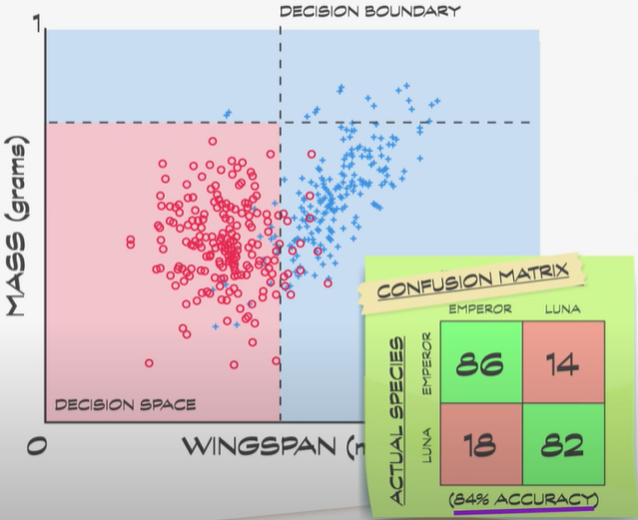In order to train a machine learning classifier to make good decisions, we need training data to make optimal separations
* 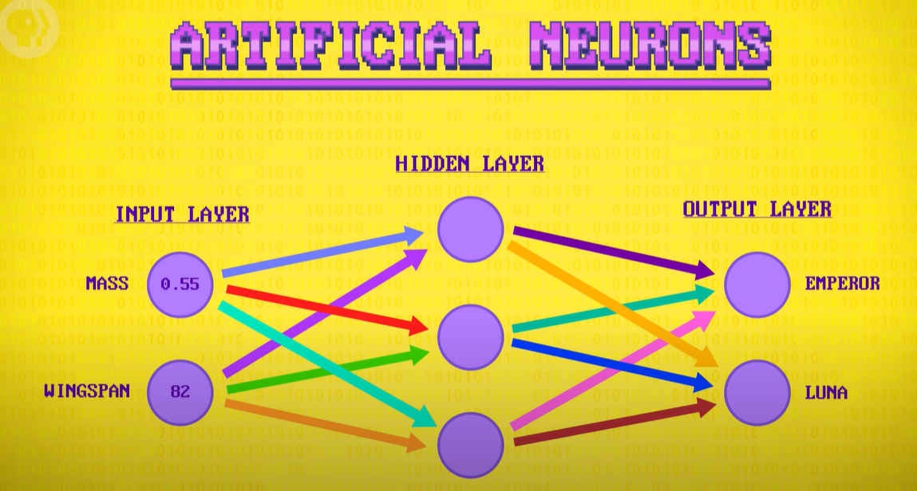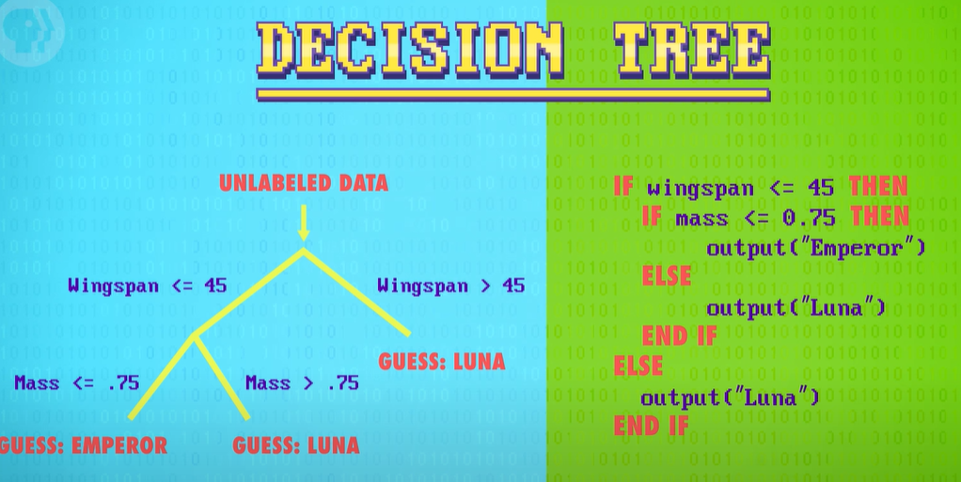An artificial neural network is an interconnected group of nodes, inspired by a simplification of neurons in a brain.

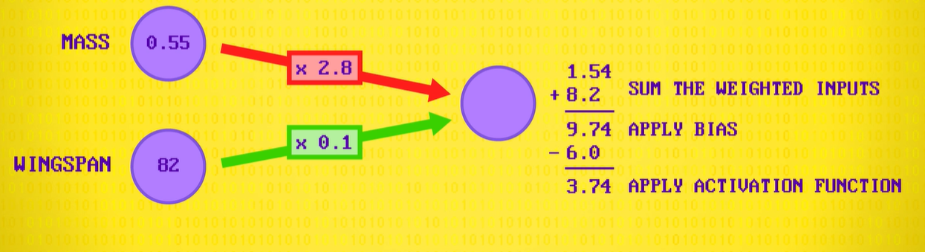

* Firstly, nodes are multiplied by a number and summed. A bias is then added to this, where something is added or multiplied. Then you add an activation function, which can get your value in a range like 1 to -1

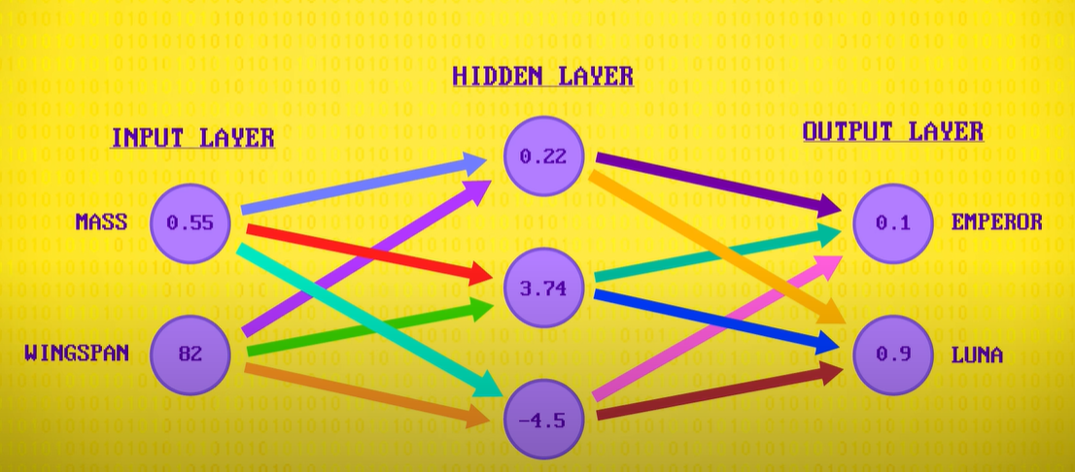

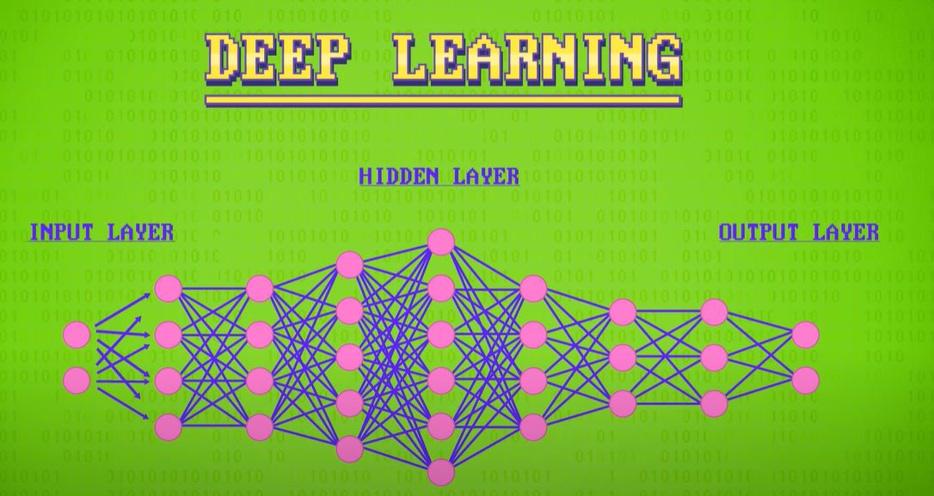

* Deep learning -> large neural networks, deep
* Weak AI/narrow AI -> only focus on one thing
* Strong AI -> general purpose AI, all rounded like humans
* AI vs Human player playing Alpha Go-> One of the ways it got so good and able to beat the very best human players, was by playing clones of itself millions and millions of times. This is reinforcement learning (similar to how humans walk).

Computer Vision: Crash Course Computer Science #35

* Colour tracking for an object is rarely used unless the environment can be tightly controlled, as otherwise it is not that accurate
* Patches are used to differentiate objects

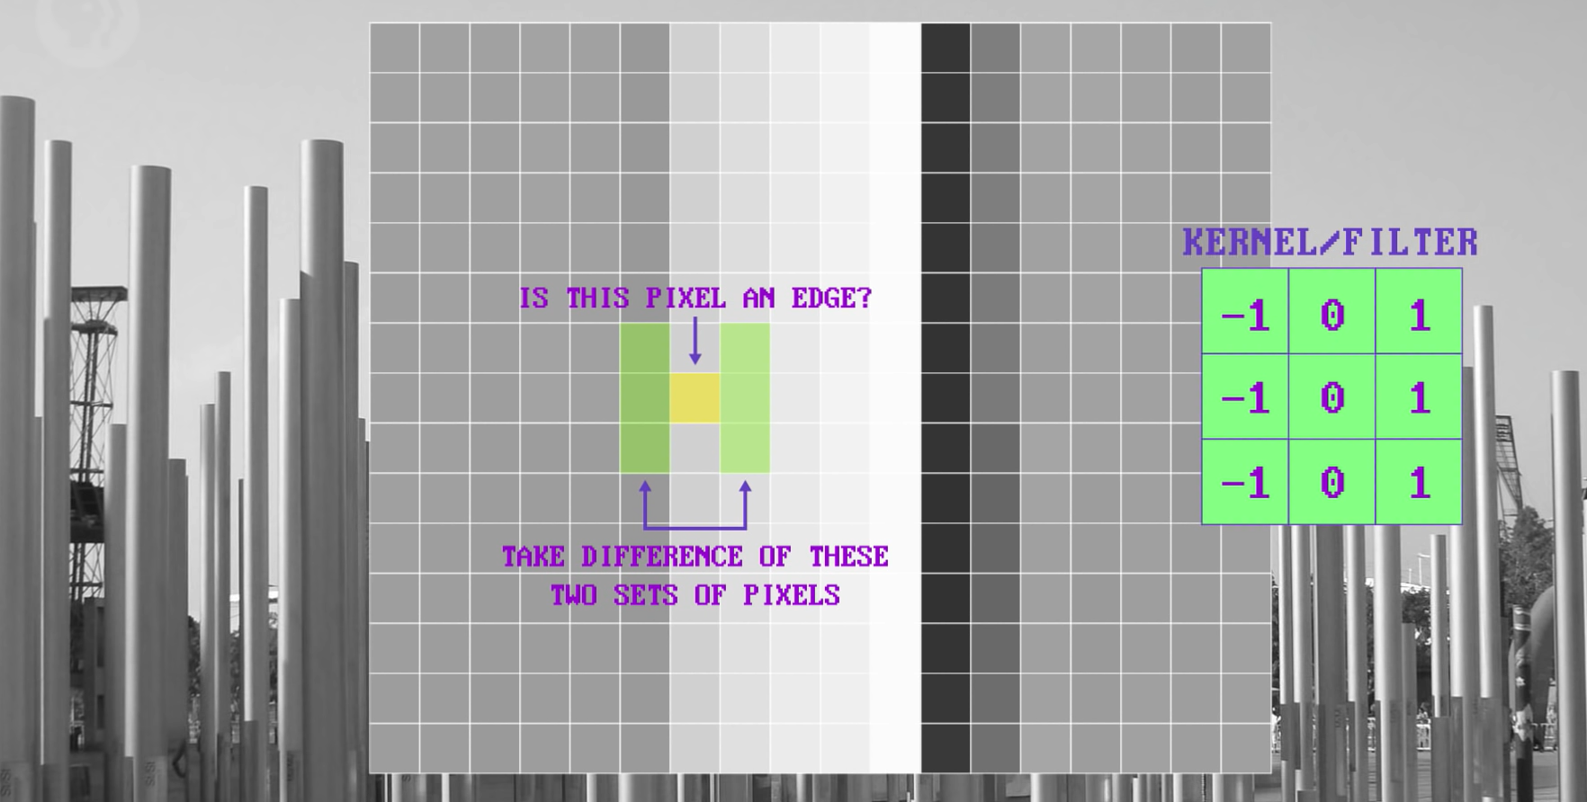

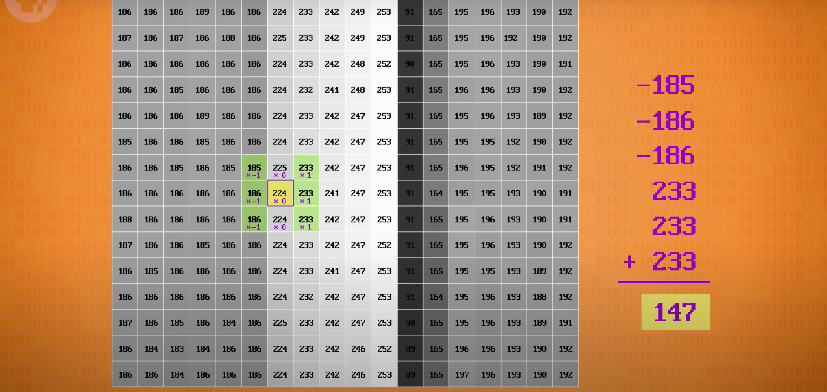

* This operation of applying a kernel to a patch of pixels, is called a convolution



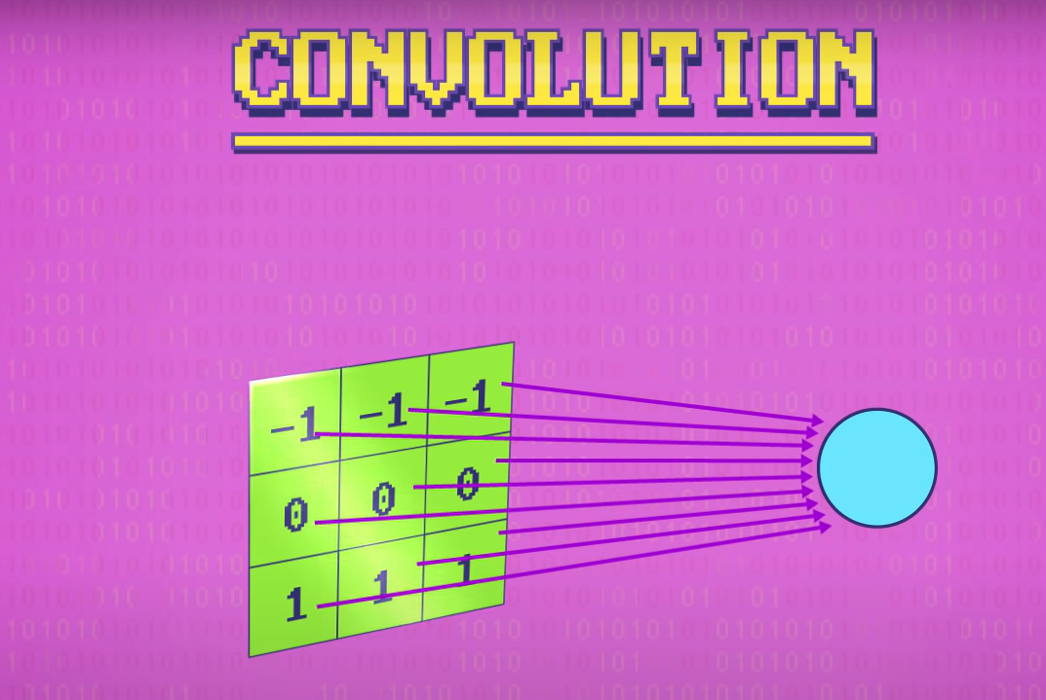

* 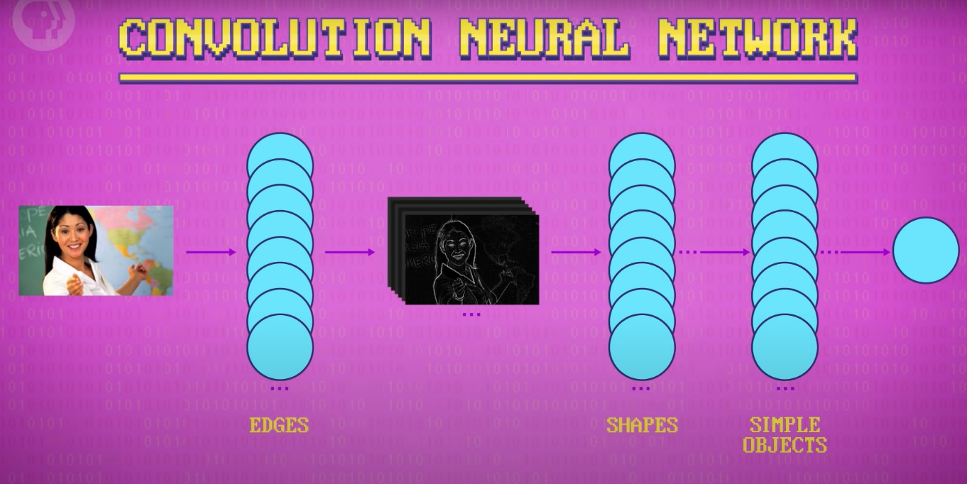We can use 2D matrix as an input for a neural network
* Convolutional neural networks aren't required to be many layers deep, but they usually are, to recognise complex objects and scenes. That's why the technique is considered deep learning.
* Context sensitive -> Computers that are aware of their surroundings.

Natural Language Processing: Crash Course Computer Science #36

* Natural languages are human languages
* NLP (Natural Language Processing) -> Combining CS with Linguistics

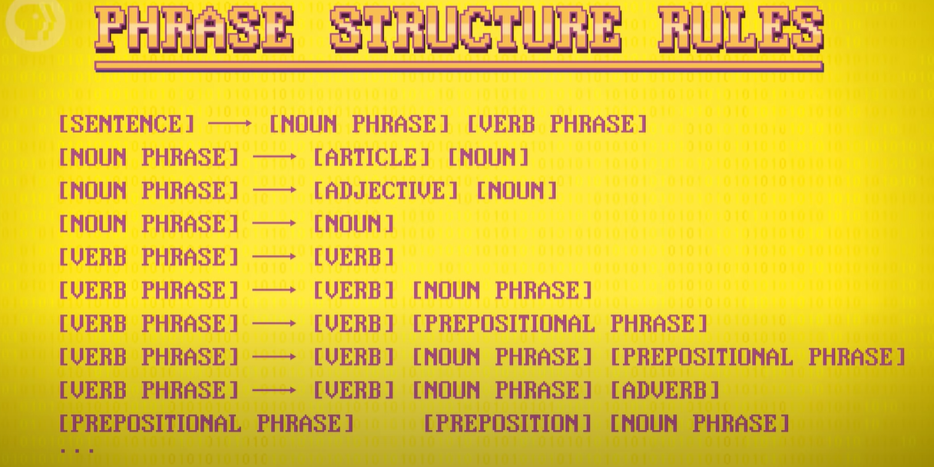

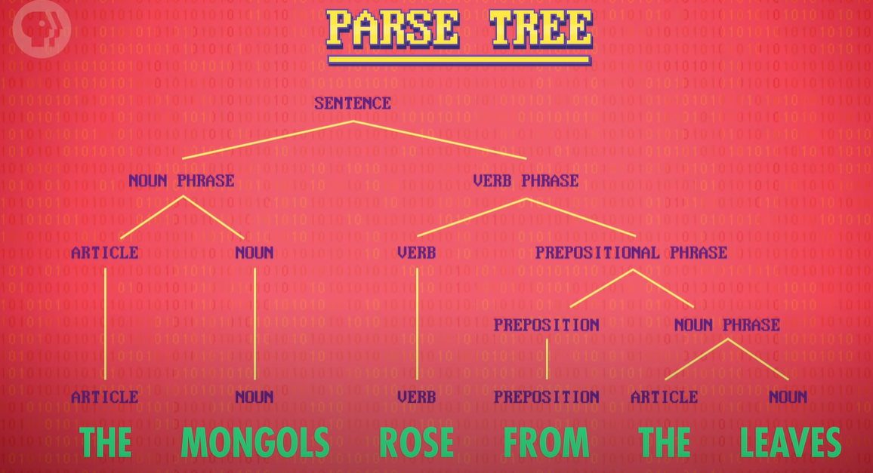

* Parsing and generating text are fundamental components of natural language chatbots – computer programs that chat with you.
* There was simultaneous innovation in the algorithms for processing natural language, moving from hand-crafted rules to machine learning techniques that could learn automatically from existing data sets of human language.
* Phrase structure rules can be used to generate natural language text, this works particularly well when data is stored in a web of semantic information, where entities are linked to one another in meaningful relationships, providing all the ingredients you need to craft informational sentences.
* Speech recognition -> use deep neural networks using spectrograms, using a fast Fourier transform
* Speech recognition is vastly improved by using language models, which contains statistics about sequences of words.
* Speech Synthesis -> ability to give computers ability to give out speech through speaker

Robots: Crash Course Computer Science #37

* Robots-> A machine that lives in and acts in the real world
* CNC (Computer Numerical Control)-> Could run a series of instructed operations
* 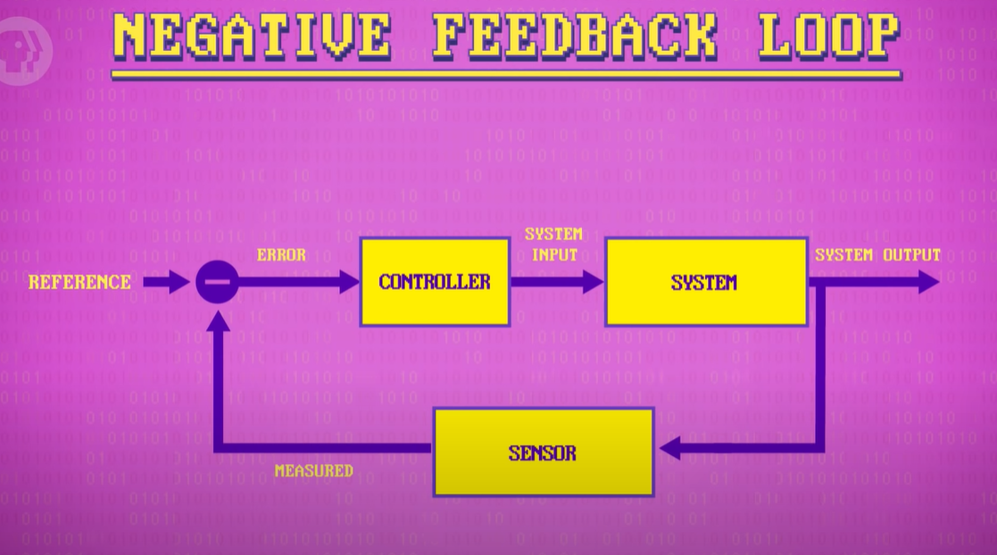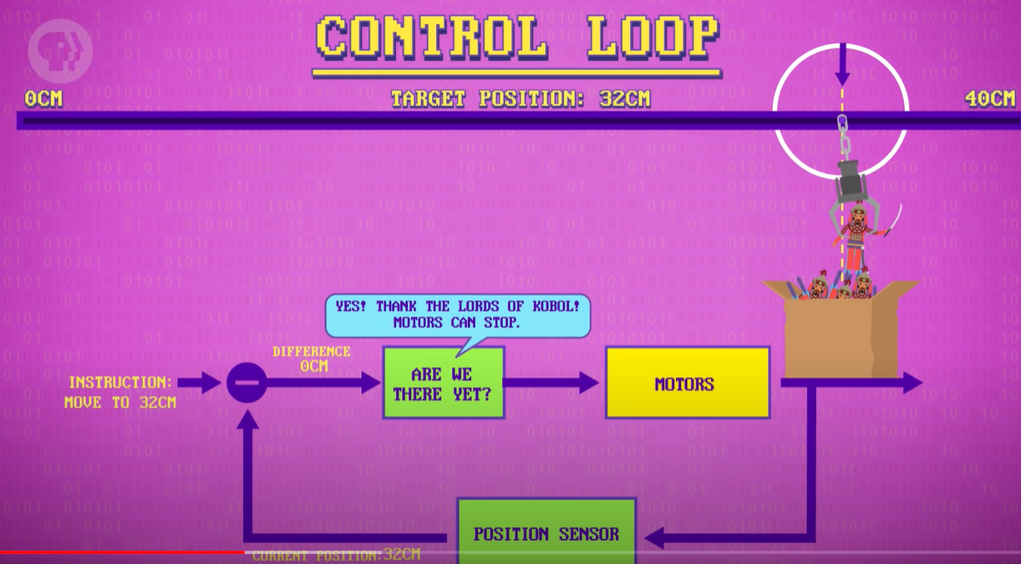First industrial robot 1960 -> Unimate, this lifted hot pieces of metal and stacked them and had systematic tasks stored in a drum memory
* PID controllers (proportional-integral-derivative controller) ->

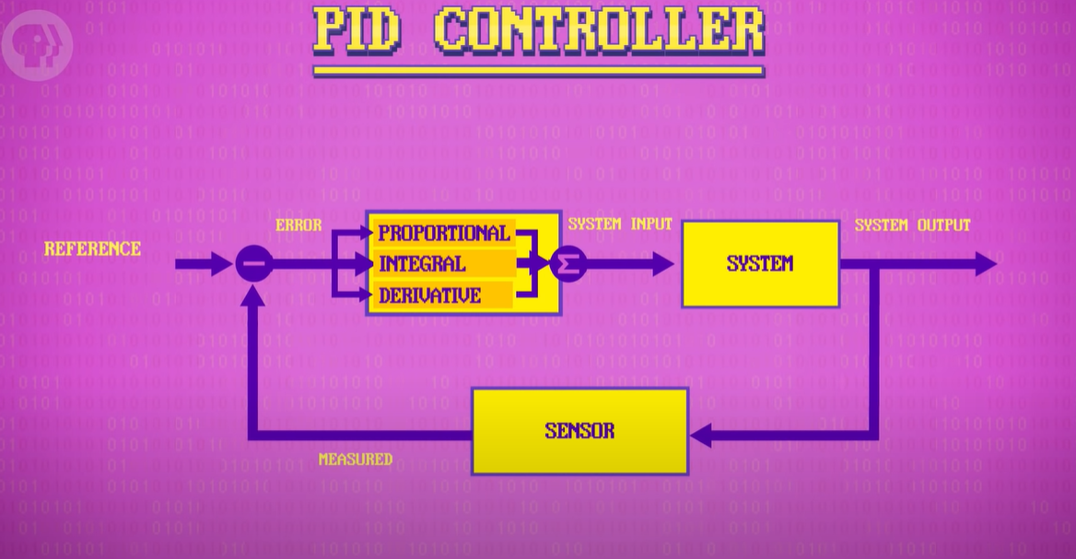

* Advanced robots often require many control loops running in parallel, working together, managing everything from robot balance to limb position
* Androids -> robots that look and act like humans

Psychology of Computing: Crash Course Computer Science #38

* Usability -> The degree to which a human made artifact can be used to achieve an objective effectively and efficiently
* Intensity of colour (e.g., Dark -> Light) is easy for humans, but type of colour is good for distinguishing groups of data
* Chunked -> When items are put together into small, meaningful groups e.g., Telephone numbers
* Chunking is used in drop down menus

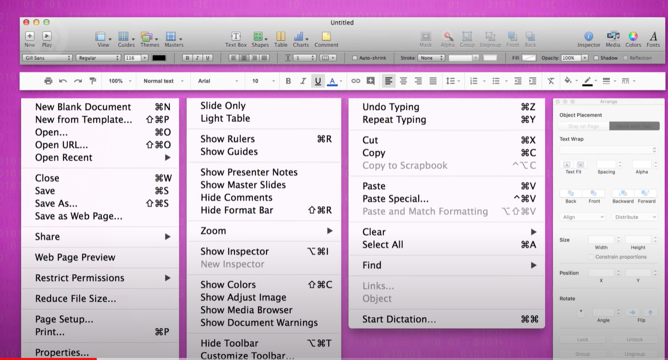

* Affordances -> affordances provide strong clues to the operations of things. Plates or for pushing. Knobs offered turning. Slots offer inserting things to do. When affordances are taken advantage of, the user knows what to do just by looking; No picture, label, or instruction needed. E.g., if you have pushed a pull door, affordance has been broken, the door should have a push plate
* Knurling -> texture added to objects to improve grip and show where to best grab them.
* As you gain experience with interfaces, you get faster, building mental models of how to do things effectively. So, good interfaces should offer multiple paths to accomplish goals. E.g., copy and paste, a novice can use right click whilst an expert can use keyboard shortcut.
* Affect -> computers responding to human’s emotional state
* We can use sensors to figure out emotions, this multi modal sensor data is used in conjunction with computational models that represent how people develop and express affective states, like happiness and frustration, and social states, like friendships and trust
* Computer Mediated Communication (CMC) -> One interesting finding is that people exhibit higher levels of self-disclosure – that is real personal information – in computer mediated conversations compared to face-to-face interactions
* Mutual gaze -> Direct eye contact, good for capturing attention. In video lectures, this rarely happens so not good for attention. We can use augmented gaze to achieve this
* HRI (Human Robotic Interaction) -> Field dedicated to understanding robot’s interactions with humans

Educational Technology: Crash Course Computer Science #39

* Videos are naturally adjustable, so make sure the pacing is right for you by adjusting speed and rewinding. You can pause, asking yourself questions about difficult parts. You can also try to do examples yourself before watching the video.
* Online Learning can use algorithms, by optimizing results. For instance, computer algorithms that create the writing portions of the SATs have been found to be just as accurate as humans hired to grade them by hand.
* Intelligent tutoring systems -> Software can present the right material, at the right time, to give each learner practice on the things that are hardest for them, rather than what they are already good at. (This is powered by AI)
* Domain model -> A formal representation of the knowledge, procedures, and skills of a particular discipline.
* Intelligent tutoring systems build and maintain a student model, one that tracks among other things what production rules a student has mastered, and where they still need practice
* A challenge is to know what a student understands and does not through their answers to problems. a common technique for figuring this out is beige and knowledge tracing period the algorithm treats student knowledge as a set of variables, which are variables whose true value is hidden from an outside observer, like our software
* Probabilities -> Probability that a student has learned, probability of guess, probability of slip and probability of transit
* 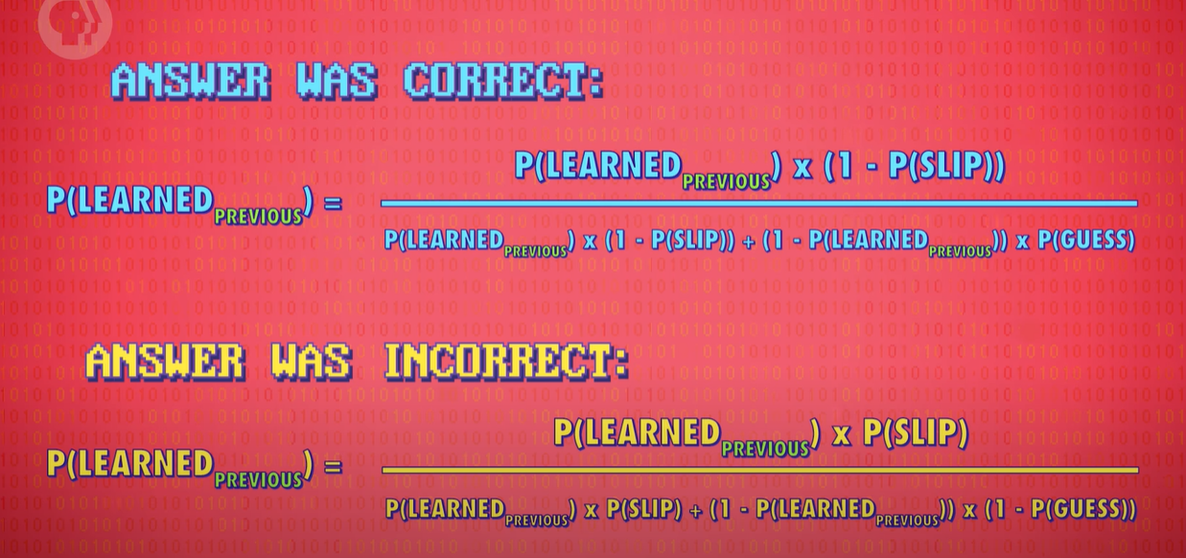Educational data mining -> Collects data from students to improve for other students

The Singularity, Skynet, and the Future of Computing: Crash Course Computer Science #40

* Ubiquitous computing -> concept in software engineering and computer science where computing is made to appear anytime and everywhere e.g. smart fridge, smart washing machine.

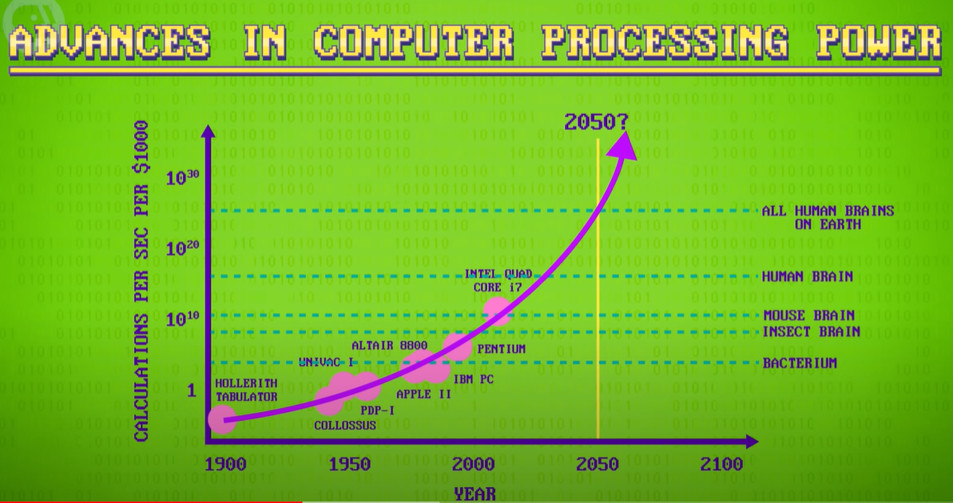

* 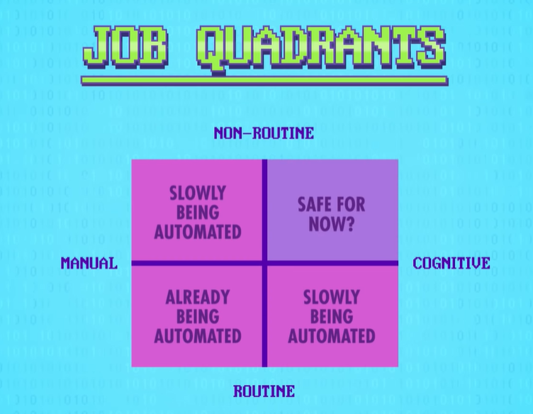Technological unemployment -> workers made redundant by computers